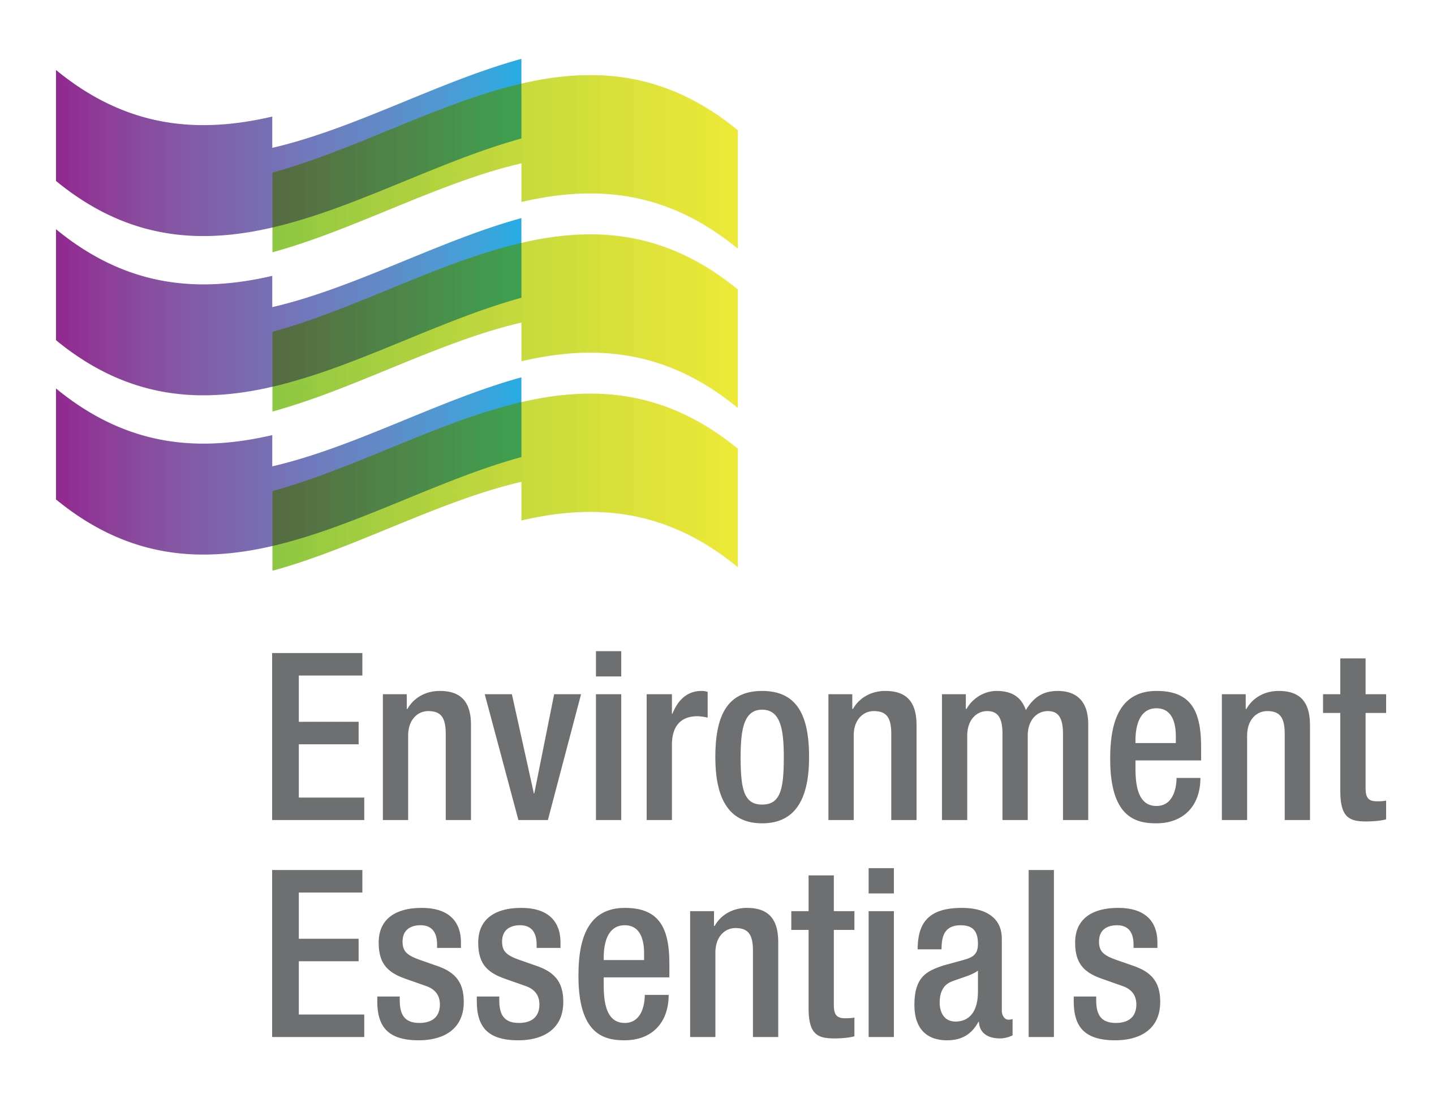 | COVID-19 (Novel Coronavirus)

Wednesday 10 August 2022
Please find below a selection of recent legislation changes relating to COVID-19 and communications for workplaces from key safety and environmental regulators in Australia and New Zealand.
This update is intended to be provided on a weekly basis.
Please note: The legislation in this update was current at time of release. Legislation around COVID-19 is being frequently updated and revoked. The URLs provided may no longer be maintained by the relevant legislation website, after the release date.

Legislation changes

ACT
- Public Health (Emergency) Declaration Further Extension 2022 (No 3) - Further extends the period during which the Public Health (Emergency) Declaration 2020 (No 1) is in force for a period of 50 days.

TAS
- Direction Under Section 16 (Isolation - No. 7) - Sets the isolation requirements for persons diagnosed with COVID-19.
- Direction Under Section 16 (Quarantine - No. 11) - Sets the quarantine requirements close contacts, with requirements for aged care workers and critical care workers, among other things.

WA

Extension of State of Emergency Declaration - Extends the state of emergency for a period of 14 days.

From the regulators

Australia

Australian Government: Meeting of National Cabinet

Department of Health and Aged Care:

ATAGI Recommendations On COVID-19 Vaccine Use in Children Aged 6 Months to <5 Years

ATAGI Update Following Weekly COVID-19 Meeting - 3 August 2022
  - New COVID-19 Safe Behaviours Campaign

ACT

ACT Government:
  - Canberra, Mask Up to Protect Our Community
  - Public Health Emergency Declaration Extended

TAS

Tasmanian Government:
  - Antiviral Medication
  - PCR Testing Announcement

WA

WA Government:
  - COVID-19 Vaccinations Now Recommended for Some Young Children Aged 6 Months to 5 Years
  - Text-to-speech Now Available for COVID-19 Information

That completes this edition of the COVID-19 update. The next update will be released on Wednesday 17 August 2022.

Environment Essentials Pty Ltd ǀ ABN: 29 103 207 638
A Suite 8 / 8 Clay Drive, Doncaster Vic 3108, Australia ǀ T +61 3 9095 6533
W www.enviroessentials.com.au

