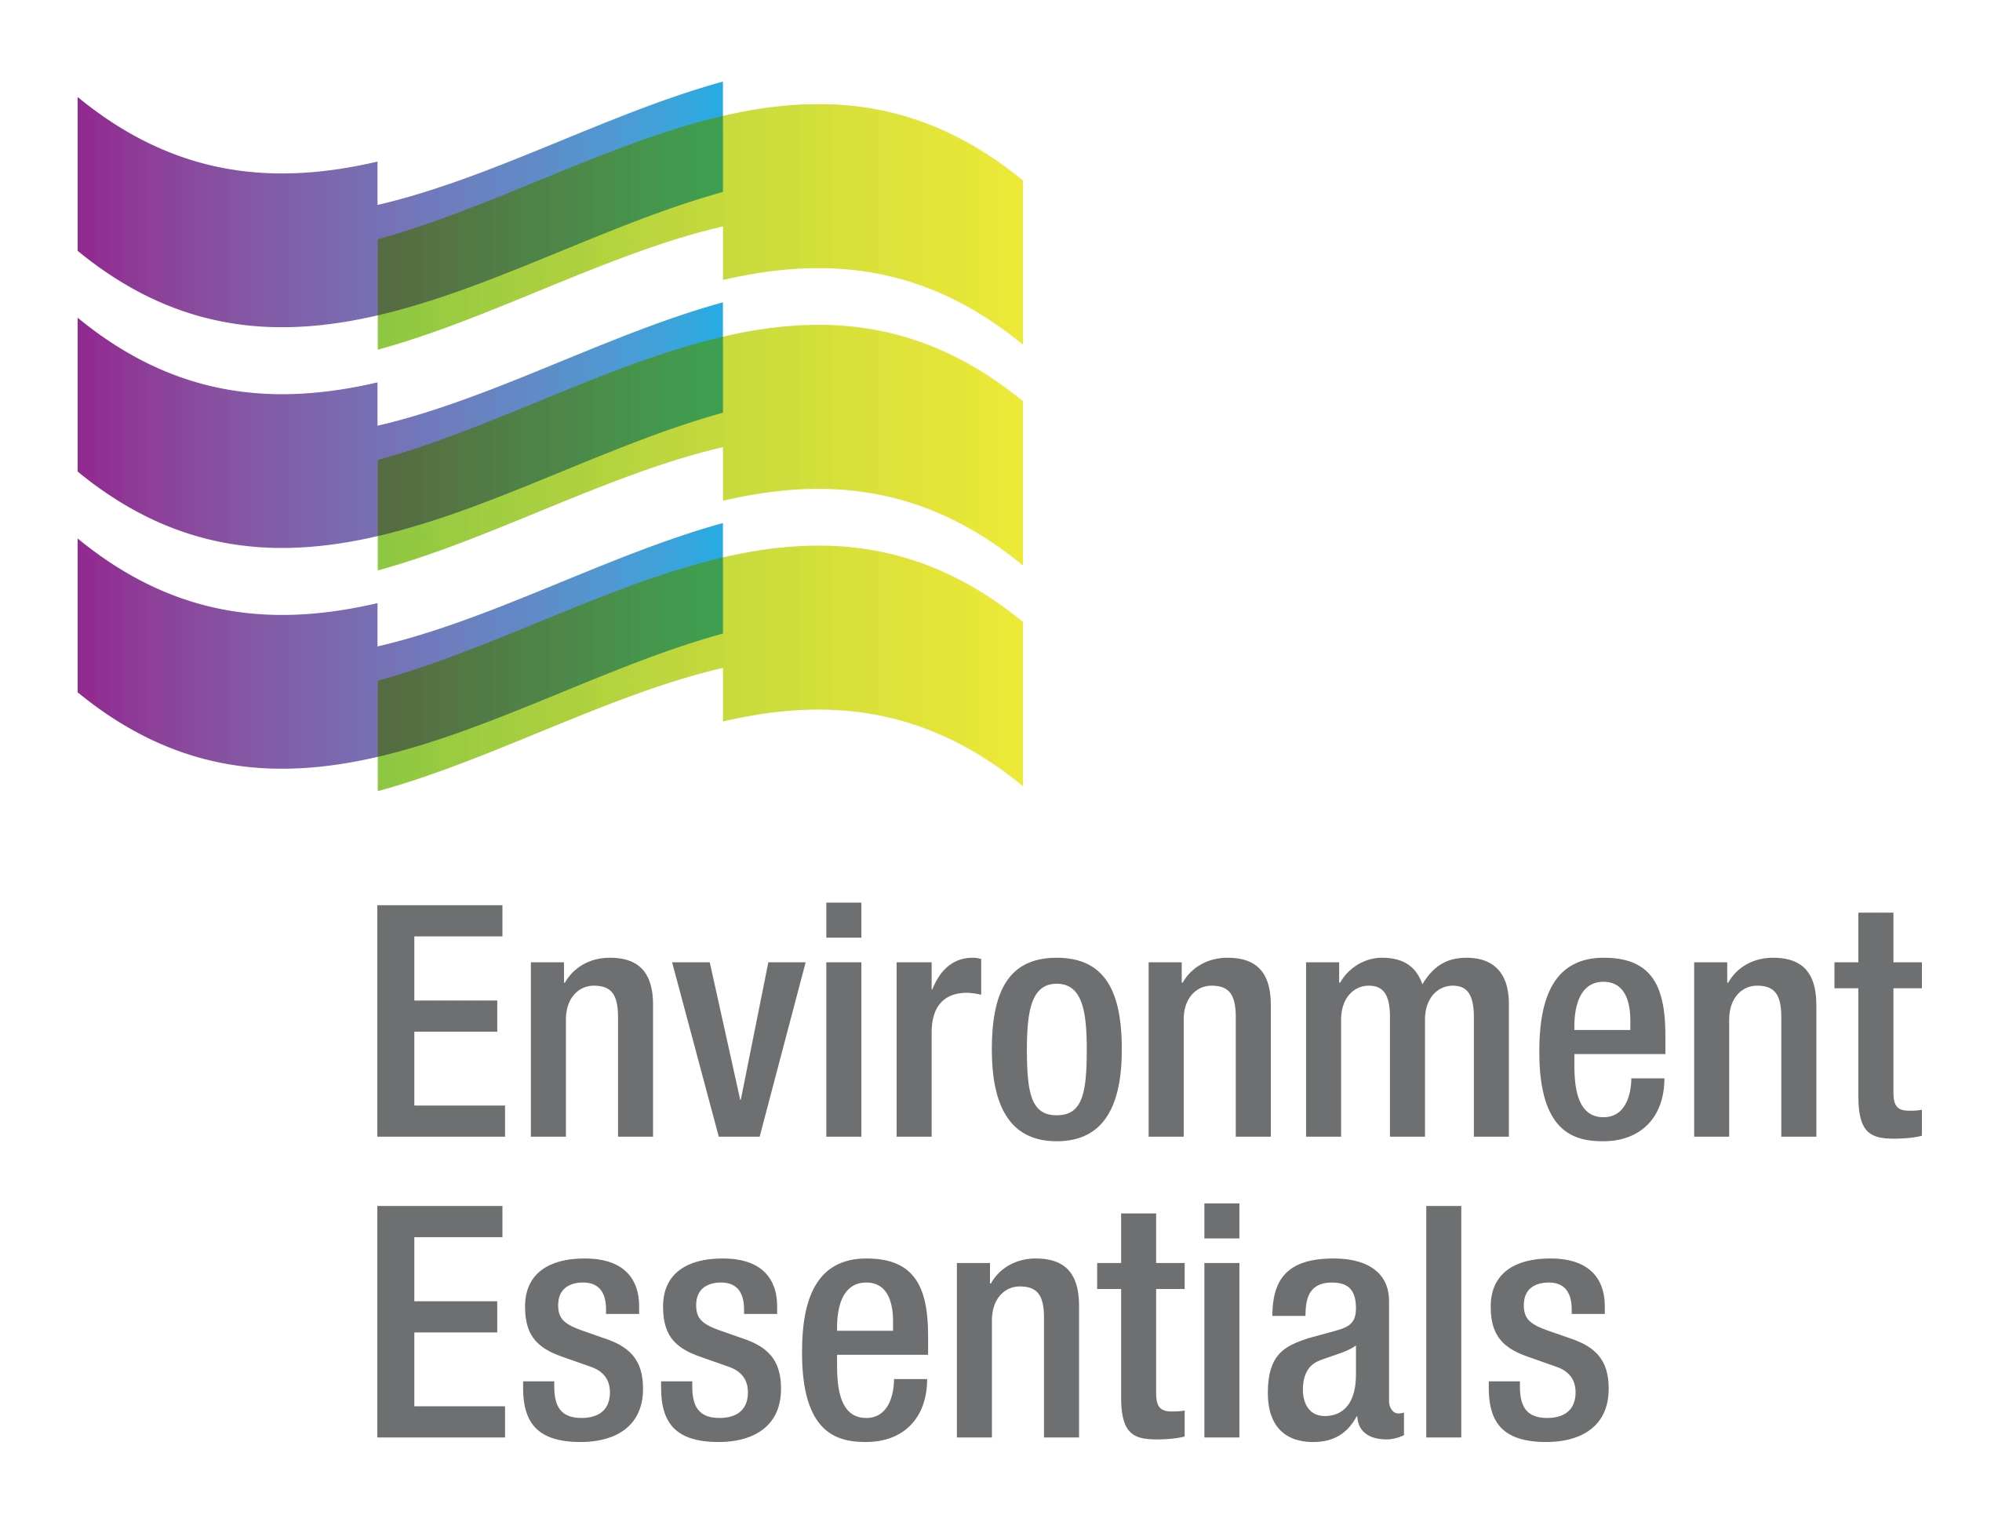 | COVID-19 (Novel Coronavirus)

Wednesday 18 May 2022
Please find below a selection of recent legislation changes relating to COVID-19 and communications for workplaces from key safety and environmental regulators in Australia and New Zealand.
This update is intended to be provided on a weekly basis.
The legislation in this update was current at time of release. Legislation around COVID-19 is being frequently updated and revoked. The URLs provided may no longer be maintained by the relevant legislation website, after the release date.

Please note: From 25 May 2022, the scope of this update will be limited to COVID legislation and news that directly affects workplaces.

Legislation changes

Commonwealth
- Commonwealth Electoral (Secure Telephone Voting Method for Coronavirus Affected Individuals) Determination 2022 - Provides that the secure telephone voting method prescribed by the Commonwealth Electoral (COVID Enfranchisement) Regulations 2022 may be used by individuals referred to in Section 202AFA(1) in relation to the general election and Senate election to be held in the year beginning 1 January 2022.

ACT
- Public Health (Emergency) Declaration Further Extension 2022 (No 2) - Further extends the period during which the Public Health (Emergency) Declaration 2020 (No 1) is in force for a period of 90 days.
- Public Health (Restricted Activities) Emergency Direction 2022 (No 7) - Requires restricted businesses, activities and undertakings and certain public events to operate in accordance with COVID-19 safety plans to limit the public health risk posed by COVID-19.

QLD
- Disability Accommodation Services Visitor Direction (No. 2) - Imposes requirements in relation to visiting disability accommodation services.
- Hospital Visitor Entry Direction (No. 2) - Imposes requirements in relation to visiting hospitals.
- Requirements for Workers at Government Nominated Accommodation Direction (No. 2) - Protects the health of the community and individuals working and staying in government accommodation for isolation by mitigating the risk of the spread of COVID-19, including through vaccination, personal protective equipment and COVID-19 testing requirements for workers.
- Residential Aged Care Visitor Direction (No. 2) - Imposes requirements in relation to visiting residential aged care facilities.

TAS
- Notice Under Section 20 of the COVID-19 Disease Emergency (Miscellaneous Provisions) Act 2020 - Declares certain exceptions to the Criminal Code, Criminal Code Act 1942, Sentencing Act 1997 and Supreme Court Civil Procedure Act 1932.

WA

Extension of State of Emergency Declaration - Extends the state of emergency declaration for a period of 14 days.
- Maritime Crew Member Directions (No 10) - Sets out the requirements that apply to unvaccinated international maritime crew members entering Western Australia by disembarking a vessel.

NZ
- COVID-19 Public Health Response (Air Border) Order 2021 - Specified Information and Form of Traveller Pass for New Zealand Traveller Declaration System (No 2) - Specifies information for certain travellers required to make a declaration through the New Zealand Traveller Declaration System.
- Special Direction - Extension of Visas Held by a Class of Work to Residence Visa Holders, and Their Partners and Dependent Children, to Manage the Effects and Deal with the Consequences of Measures Taken to Contain or Mitigate the Outbreak of COVID-19 or its Effects - Extends the visas held by certain classes of people.
- Special Direction - Grant of Temporary Visas to Classes of People to Manage Effects and Deal with Consequences of Measures Taken to Contain or Mitigate the Outbreak of COVID-19 or its Effects - Grants a temporary visa to certain classes of people.

From the regulators

Australia

Therapeutic Goods Administration:
  - Batch Release Assessment of COVID-19 Vaccines
  - TGA Commences Evaluation of Moderna COVID 19 Vaccine (SPIKEVAX) for Children Aged 6 Months to 5 Years Old
  - TGA Removes Age Limit for BBIBP-CorV (Sinopharm) COVID-19 Vaccine Recognition for International Travel to Australia

ACT

ACT Government:
  - AIS Arena COVID-19 Mass Vaccination Clinic to Close but Free Vaccines Still Available
  - Check In CBR App No Longer Mandatory, Upgraded for Use as Health Screening Tool

NT

NT Government: Excluded Communities

TAS

Tasmanian Government: Voting Options for People with COVID-19

WA

WA Government: Drive-Through Collection Sites to Open for Free RATs for Close Contacts

NZ

NZ Government:
  - Avoid COVID Reinfection This Winter
  - Fully Open Border and Immigration Changes Speed Up Economic Growth
  - Updated My Vaccine Pass for Those Who Want It

That completes this edition of the COVID-19 update. The next update will be released on Wednesday 25 May 2022.

Environment Essentials Pty Ltd ǀ ABN: 29 103 207 638
A Suite 8 / 8 Clay Drive, Doncaster Vic 3108, Australia ǀ T +61 3 9095 6533
W www.enviroessentials.com.au

