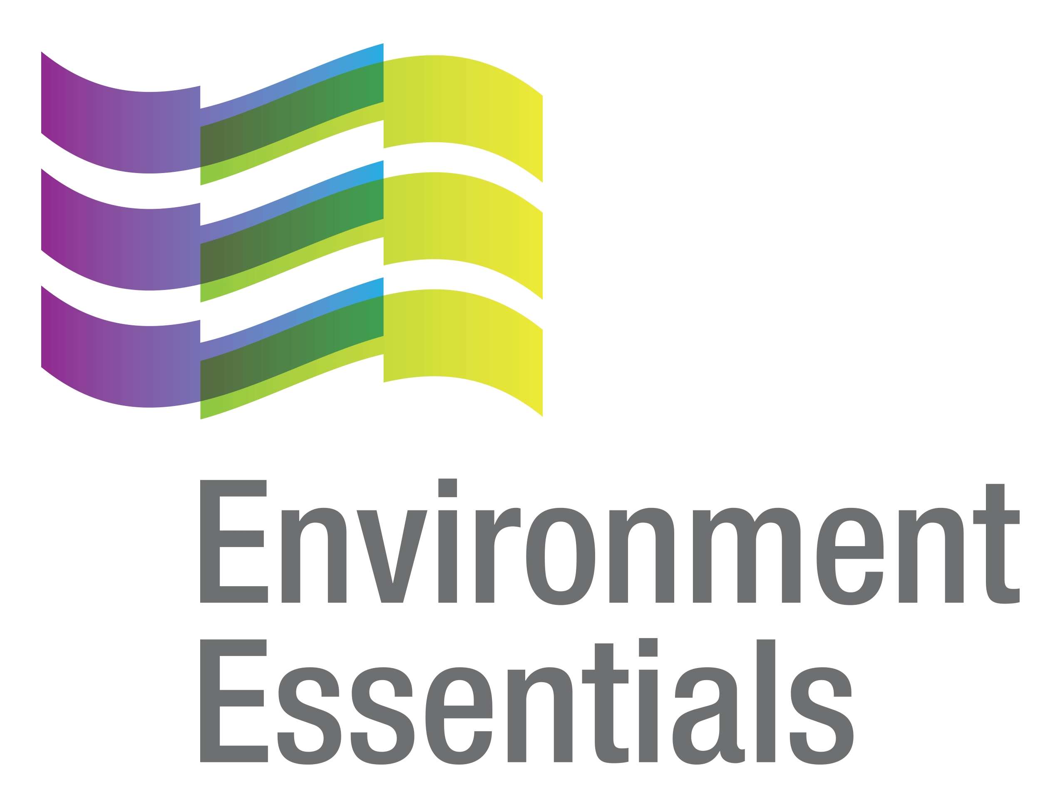 | COVID-19 (Novel Coronavirus)

Wednesday 1 December 2021
Please find below a selection of recent legislation changes relating to COVID-19 and communications for workplaces from key safety and environmental regulators in Australia and New Zealand.
This update is intended to be provided on a weekly basis.
Please note: The legislation in this update was current at time of release. Legislation around COVID-19 is being frequently updated and revoked. The URLs provided may no longer be maintained by the relevant legislation website, after the release date.

Legislation changes

Commonwealth
- Biosecurity (Emergency Requirements - High Risk Country Travel Pause) Determination (No. 2) 2021 - Requires passengers on a relevant international flight not to enter Australian territory at a landing place if the person has been in an Omicron high risk country (Botswana, Eswatini, Lesotho, Malawi, Mozambique, Namibia, Seychelles, South Africa and Zimbabwe) within 14 days of the day the flight was scheduled to commence, unless an exemption set out in Section 7 applies to the person.
- Biosecurity (Entry Requirements - Human Coronavirus with Pandemic Potential) Determination (No. 2) 2021 - Sets out new entry requirements for people who are entering Australia at a landing place.

ACT
- Public Health (Restricted Activities) Emergency Direction 2021 (No 7) - Imposes restrictions on certain businesses, activities and undertakings in relation to occupancy and density limits at premises, and the requirement to operate in accordance with COVID-19 safety plans where applicable to minimise the public health risk posed by COVID-19 in the Australian Capital Territory.
- Public Health (Returned Travellers) Emergency Direction 2021 (No 5) - Requires persons travelling from overseas to either quarantine or be tested for COVID-19, depending on whether or not the person has been fully vaccinated, in order to limit the spread of COVID-19.

NSW

Exemption Under the Public Health (COVID-19 General) Order 2021 Under the Public Health Act 2021 - Exempts the occupier of premises being used to hold a school's formal, dinner, or graduation (school event) from Clause 2.18(1) and (3) of the Public Health (COVID-19 General) Order 2021 subject to certain conditions - came into force on 24 November 2021.

Public Health (COVID-19 Air Transportation Quarantine) Order (No 4) 2021 - Repeals and remakes, with some changes, the Public Health (COVID-19 Air Transportation Quarantine) Order (No 3) 2021 - came into force on 27 November 2021.

Public Health (COVID-19 Air Transportation Quarantine) Order (No 4) Amendment (Omicron Variant) 2021 - Amends the Public Health (COVID-19 Air Transportation Quarantine) Order (No 4) 2021 to insert special provisions in response to the emergence of the Omicron variant - came into force on 28 November 2021.
- Public Health (COVID-19 Air Transportation Quarantine) Order (No 4) Amendment (Transiting Arrivals) 2021 - Amends the Public Health (COVID-19 Air Transportation Quarantine) Order (No 4) 2021 in relation to persons arriving in NSW from other countries and the meaning of "most practicable direct route" - came into force on 28 November 2021.

Public Health (COVID-19 Maritime Quarantine) Order (No 4) 2021 - Repeals and remakes, with some changes, the Public Health (COVID-19 Maritime Quarantine) Order (No 3) 2021 - came into force on 27 November 2021.

NT
- COVID-19 Directions (No. 102) 2021: Directions for Intra-Territory Travel - Specifies circumstances where a person is allowed to exit Katherine and enter an approved home quarantine zone, sets quarantine requirements, and specifies testing requirements for persons who exit Katherine under the Directions.
- COVID-19 Directions (No. 105) 2021: Directions for Hard Lockdown in Binjari - Requires closure of certain places, businesses, services and activities, and restricts movement and gatherings, in the locality of Binjari.
- COVID-19 Directions (No. 106) 2021: Directions to Lock Out Katherine - Restricts movement and gatherings, and imposes vaccination status requirements, in the municipality of Katherine, except for the locality of Binjari.
- COVID-19 Directions (No. 107) 2021: Amendments to COVID-19 Directions (No. 102) 2021 - Makes amendments to COVID-19 Directions (No. 102).
- COVID-19 Directions (No. 108) 2021: Directions to Lock Down Lajamanu and Homelands - Requires certain places, businesses, services and activities to close, and restricts movement and gatherings, in the community known as Lajamanu and homelands as specified in the Directions.
- COVID-19 Directions (No. 109) 2021: Exiting a Lockdown Area of Lockout Area to Leave the Territory by Road - Imposes requirements for exiting a lockdown area or lockout area to leave the Territory by road.
- COVID-19 Directions (No. 110) 2021: Directions for PCR Testing for Arrivals from South Australia - Imposes requirements for persons entering the Territory, who have been in South Australia in the last 14 days, to produce a negative result to a PCR COVID-19 testing procedure within 72 hours prior to entry.

QLD
- Border Restrictions Direction (No. 55) - Imposes requirements for entry to Queensland, face masks, Queensland border declaration passes, quarantine, and stay at home requirements.
- Justice and Other Legislation Amendment Act 2021 - Makes amendments to legislation in the Justice portfolio to make permanent particular parts of certain temporary measures introduced during the COVID-19 emergency.

SA
- Emergency Management (Arrivals - Associated Direction No 3) (COVID-1) Direction 2021 - Operates as an appendix to the General Directions, and sets out the requirements applying to arrivals from specified locations.
- Emergency Management (Electricity Supply Emergencies) Amendment Act 2021 - Amends the Emergency Management Act 2004 in relation to the Minister's power to give directions, among other things.
- Emergency Management (Passenger Transport Vaccination No 2) (COVID-19) Direction 2021 - Protects passenger transport workers from contracting COVID-19 from passengers, and reduces the risk of spread of COVID-19 by passenger transport workers to vulnerable members of the community.
- Emergency Management (Residential Aged Care Facilities No 43) (COVID-19) Direction 2021 - Ensures that appropriate measures are taken to establish controls and safeguards to protect vulnerable members of the community, including by imposing restrictions on visitors and mandating vaccination and record-keeping requirements.

TAS
- Direction Under Section 16 (Vaccination Requirements for Certain Workers - No. 10) - Requires workers at residential aged care facilities, quarantine sites, and medical or health facilities, and workers providing quarantine transport services or high intensity supports to an NDIS participant, to be sufficiently vaccinated, among other things.

VIC
- Diagnosed Persons and Close Contacts Directions (No. 35) - Requires persons diagnosed with COVID-19 to self-isolate, and persons living or in close contact with a diagnosed person to self-quarantine, to limit the spread of COVID-19 - came into force at 6:00 pm on 25 November 2021.
- Open Premises Directions (No. 7) - Imposes obligations upon operators of certain open premises in the State of Victoria, and patrons that attend those premises - came into force at 6:00 pm on 25 November 2021.
- Stay Safe Directions (Victoria) (No. 30) - Requires everyone who ordinarily resides in the State of Victoria to carry and wear face coverings in certain settings, and imposes requirements relating to vaccinations - came into force at 6:00 pm on 25 November 2021.
- Victorian Border Crossing Permit Directions (No. 41) - Provides a scheme for persons entering Australia as an international passenger arrival or international aircrew services worker, in order to limit the spread of COVID-19 - came into force at 11:59 pm on 27 November 2021.
- Workplace (Additional Industry Obligations) Directions (No. 58) - Establishes additional specific obligations on employers and workers in specific industries in relation to managing the risk associated with COVID-19 - came into force at 6:00 pm on 25 November 2021.
- Workplace Directions (No. 57) - Limits the number of Victorians attending Work Premises to assist in reducing the frequency and scale of COVID-19 outbreaks in Victorian workplaces and establishes more specific obligations on employers and workers in relation to managing the risk associated with COVID-19 - came into force at 6:00 pm on 25 November 2021.

WA

COVID-19 Response Legislation Amendment (Extension of Expiring Provisions) Act (No. 2) 2021 - Extends the sunset date that applies to certain parts of the Emergency Management Act 2005, and makes changes to ensure that higher penalties continue to apply to serious assaults and threats against public officers committed in the context of COVID-19 for a further 6 months beyond the current sunset date of 4 January 2022.

Designation Under the Remote Aboriginal Communities Directions No 3 - Designates certain services as essential, community or human services and supplies for the purposes of sub-paragraph 10(o) of the Remote Aboriginal Communities Directions No. 3.
- Extension of Declaration (No.3) of Public Health State of Emergency - Extends the public health state of emergency for a period of 14 days
- Presentation for Testing (Airport Workers - Direct International Arrivals) Directions - Revokes the Presentation for Testing (Airport Workers - International Arrivals) Directions (No 4) and provides for certain continued obligations under those Directions.
- Presentation for Testing Directions (No 36) - Imposes requirements for persons entering WA to present for testing.
- Regulated Entry of Higher Risk Vessels into Western Australia Directions (No 2) - Regulates to entry of higher risk vessels into WA to prevent the importation of COVID-19.

NZ
- COVID-19 Public Health Response (Air Border) Order (No 2) Amendment Order (No 14) 2021 - Makes changes to designate Botswana, Eswatini, Lesotho, Malawi, Mozambique, Namibia, Seychelles, South Africa, and Zimbabwe as very high risk countries, and to remove Brazil, Fiji, India, Indonesia, and Pakistan from the list of very high risk countries.
- COVID-19 Public Health Response (COVID-19 Vaccination Certificate) Order 2021 - Provides for the issue of COVID-19 vaccination certificates (CVCs).
- COVID-19 Public Health Response (Vaccinations) Amendment Order (No 5) 2021 - Amends the COVID-19 Public Health Response (Vaccinations) Order 2021 in relation to authorising affected persons to carry out certain work, duties of PCBUs in regard to record keeping and registers, the period for which police employees are considered to be vaccinated and certain affected workers who are not vaccinated, among other things.
- COVID-19 Response (Vaccinations) Legislation Act 2021 - Amends the COVID-19 Public Health Response Act 2020 in relation to COVID-19 orders, acceptable evidence of compliance with COVID-19 orders, protection of personal information from COVID-19 vaccination certificates, producing evidence of compliance with an order, vaccination or testing mandates, and creation of regulations, and amends the Employment Relations Act 2000 in relation to time off for employees to be vaccinated, and notice periods for termination, among other things.
- Land Transport Rule: COVID-19 Response Amendment 2021 - Allows for drivers to continue to be licensed and to be able to use endorsements and identification cards, when restrictions imposed in response to the outbreak of COVID-19 make it impractical or unreasonable for persons to do tasks ordinarily required to enable driver licences, endorsements and driver identification cards to be renewed.
- Specification of COVID-19 Vaccines Under the COVID-19 Public Health Response Act 2020 - Declares the doses of each COVID-19 vaccine or combination of COVID-19 vaccines required for a person to be “vaccinated” for the purposes of all or any legislation in, or made under, the COVID-19 Public Health Response Act 2020 that uses this defined term.
- Taxation (COVID-19 Support Payments and Working for Families Tax Credits) Act 2021 - Amends the Tax Administration Act 1994 and the Income Tax Act 2007 in relation to the COVID-19 resurgence support payments scheme and the Working for Families tax credit settings.

From the regulators

Australia

Australian Government: Pause to Further Easing of Border Restrictions

Department of Health:
  - Additional Border Security Measures to Protect Australians from the New ‘Omicron’ COVID-19 Variant
  - ATAGI Update Following Weekly COVID-19 Meeting - 24 November 2021
  - COVID-19 Vaccination Benefit Scam
  - COVID-19 Vaccination Information Kiosks Open Now In QLD
  - Hotspot for the Purposes of Commonwealth Support Extended for the Municipality of Katherine
  - Reduction in Threshold of No Fault COVID-19 Vaccine Claims Scheme
  - Top 3 COVID-19 Vaccine Questions - Return to Work, Testing for Travel and Impacts of the Vaccine on Medical Treatments
  - Vaccine Operations Centre - Weekly Operational Update - 22 November 2021

Therapeutic Goods Administration:

COVID-19 Rapid Antigen Self-Tests that are Approved in Australia
  - Queensland Individual Fined $2,664 for Alleged Unlawful Advertising of a Homoeopathic Medicine for COVID-19

ACT

ACT Government:

COVID-19 Economic Support for Business
  - Pop-up Pfizer Vaccine Clinics (Monday 29 November to Friday 3 December)
  - Quarantine Requirements Re-Introduced for All International Arrivals
  - Visitor Restrictions

NSW

NSW Government:
  - Another Two Cases of Omicron Confirmed in NSW
  - NSW Government Takes Precautionary Steps in Response to Omicron Variant
  - Omicron Variant in Confirmed NSW Cases
  - Removing Disruptions for Schools and Families
  - Update on Further Easing of Restrictions
  - $10 Million COVID Recovery Funding to Help Border Towns Get Back on Their Feet

NT

NT Government:
  - Boosting the Territory's COVID Defences
  - COVID-19 Update: Lajamanu Enters into Lockdown
  - Lockdown Business Support Boosted
  - $10 Million to Boost COVID-19 Response

QLD

The Queensland Cabinet and Ministerial Directory: Federal Government Funds PCR Tests

SA

Department for Energy and Mining: Assessing and Managing Risk of COVID Exposures in Resources and Energy Sector

TAS

Tasmanian Government:
  - Deadline for Vaccine Requirements
  - Further Support Available for Businesses as We Prepare to Reopen Borders
  - Helping Tasmanians Access Their COVID-19 Digital Vaccination Certificate
  - Important Community Updates
  - Increased International Travel Measures in Response to New COVID-19 Strain Omicron
  - PCR Tests to be Free for Travellers Coming to Tasmania
  - Tasmania Prepared to Live with COVID-19

VIC

Victorian Government:
  - Proportionate Steps to Protect Victorians from Omicron
  - Victoria Makes Australia’s First mRNA Vaccine Candidate

WA

WA Government:
  - COVID-19 Vaccine Community Funding Program
  - Border Controls Strengthened with South Australia
  - Public Health Advice Issued for Recent Arrivals from SA
  - Roll Up for WA’s Summer Vax Drive

NZ

Ministry of Health:
  - Booster Vaccinations Start
  - Care in the Community Model for Caring for People Who Get COVID-19 in the Future
  - Ministry Adds Channels to Obtain My Vaccine Pass

NZ Government:
  - Additional Support for People Isolating at Home
  - COVID-19 Protection Framework Supported by New Testing and Contact Tracing Strategy
  - Further COVID-19 Economic Support for Cook Islands and Fiji Announced
  - Māori Vaccination Rates Reach 80% First Dose
  - New Research Provides Insights into Public Sentiment During Delta Outbreak
  - New Text Service to Support Disabled Peoples’ Vaccinations
  - Nine Countries Designated Very High Risk
  - Pacific Community Reach Vaccination Milestone
  - Reconnecting New Zealand - The Next Steps
  - Supporting New Zealanders to Recover from COVID-19 in the Community
  - Traffic Light Levels Announced
  - Update on COVID-19 Protection Framework Sector Guidance
  - Workplace Vaccination Requirements Extended to Cover Police and NZ Defence Force

Other
- World Health Organisation:
  - Classification of Omicron (B.1.1.529): SARS-CoV-2 Variant of Concern
  - Interim Statement on COVID-19 Vaccination for Children and Adolescents
  - Joint Statement on Dose Donations of COVID-19 Vaccines to African Countries
  - Update on Omicron

That completes this edition of the COVID-19 update. The next update will be released on Wednesday 8 December 2021.

Environment Essentials Pty Ltd ǀ ABN: 29 103 207 638
A Suite 8 / 8 Clay Drive, Doncaster Vic 3108, Australia ǀ T +61 3 9095 6533
W www.enviroessentials.com.au

