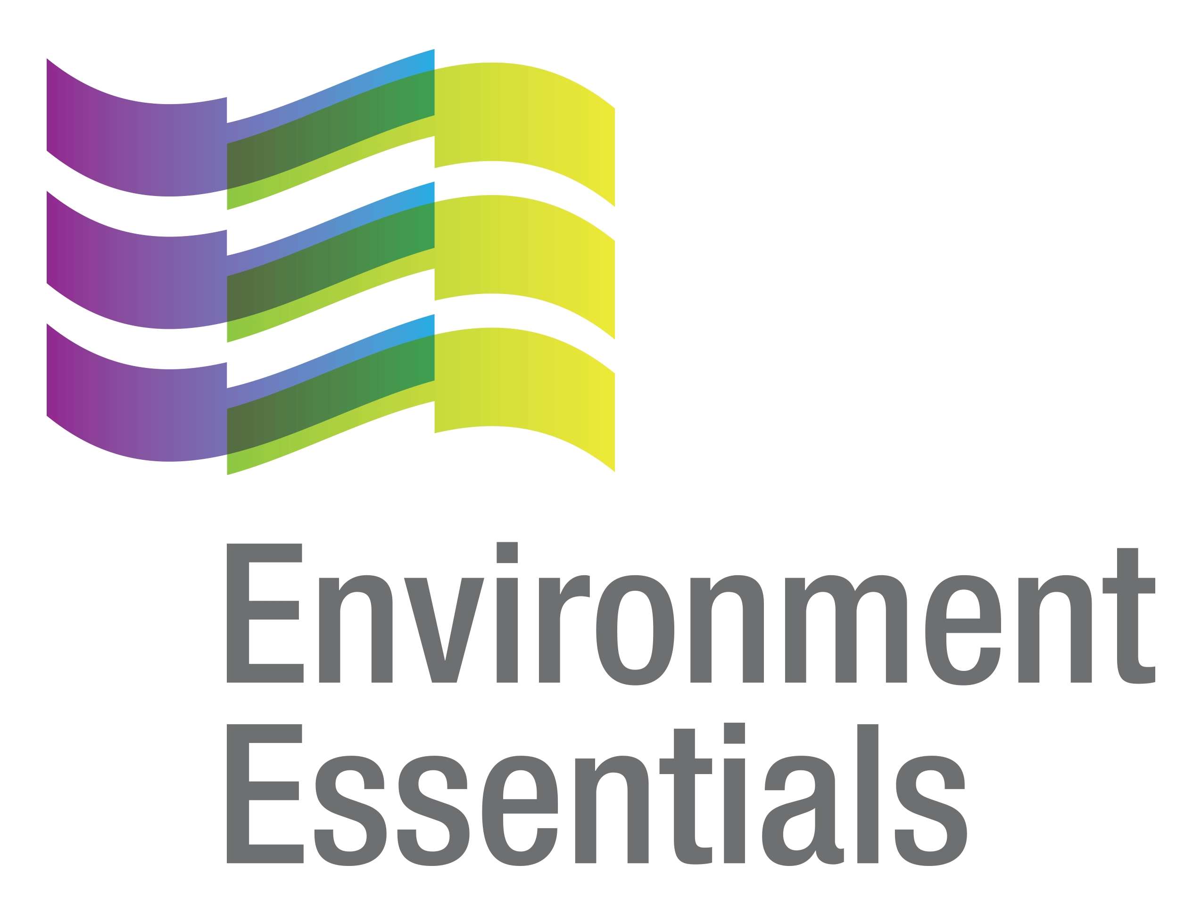 | COVID-19 (Novel Coronavirus)

Wednesday 24 November 2021
Please find below a selection of recent legislation changes relating to COVID-19 and communications for workplaces from key safety and environmental regulators in Australia and New Zealand.
This update is intended to be provided on a weekly basis.
Please note: The legislation in this update was current at time of release. Legislation around COVID-19 is being frequently updated and revoked. The URLs provided may no longer be maintained by the relevant legislation website, after the release date.

Legislation changes

Commonwealth
- Biosecurity (Emergency Requirements - Remote Communities) Determination 2021 - Determines requirements to prevent or control the entry or spread of COVID‑19 in parts of Australian territory defined as designated areas.
- Biosecurity (Emergency Requirements - Remote Communities) Amendment (No. 2) Determination 2021 - Extends the operation of the Biosecurity (Emergency Requirements - Remote Communities) Determination 2021 to 1 December 2021.

NT
- COVID-19 Directions (No. 88) 2021: Amendment of COVID-19 Directions (No. 85) 2021 - Makes amendments to the exceptions to the stay at home requirement.
- COVID-19 Directions (No. 90) 2021: Amendment of COVID-19 Directions (No. 85) 2021 - Extends the Direction until 22 November 2021.
- COVID-19 Directions (No. 91) 2021: Amendment of COVID-19 Directions (No. 86) 2021 - Amends the application of the Direction and revokes Part 4 (Restricted movement in and out of lockdown area) and Part 5 (Restrictions outside lockdown area).
- COVID-19 Directions (No. 92) 2021: Amendment to COVID-19 Direction No. 87 of 2021 - Extends the Direction until 22 November 2021.
- COVID-19 Directions (No. 94) of 2021: Hard Lockdown of Binjari and Rockhole - Directs that Direction 12(b) to (e), (g) to (j), (m) and (n) and (p) to (r) of COVID-19 Directions (No. 85) 2021 (as amended) do not apply to the locality of Binjari and the community of Rockhole (Northern Territory Portion 1533).
- COVID-19 Directions (No. 95) of 2021: Directions to Wear Face Masks in Roper Gulf and Victoria-Daly - Requires persons to wear a face mask while in the LGA’s of Roper Gulf and Victoria-Daly, when the person is outside the premises where the person resides and the person is within 1.5 m of another person who does not reside at the same premises.
- COVID-19 Directions (No. 96) of 2021 - Directions for Territory Border Restrictions - Restricts entry to the Territory, sets the requirements for declaration and screening, quarantine and testing on arrival in the Territory, among other things.
- COVID-19 Directions (No. 97) 2021: Directions to Lock Out Robinson River and Surrounding Homelands - Restricts, in Robinson River and surrounding homelands as described in the Direction, movement in and out of, and within, the lockout area, restricts gatherings and requires vaccination status to be checked at certain places.
- COVID-19 Directions (No. 98) 2021: Amendments to COVID-19 Directions (No. 85) 2021 and COVID-19 Directions (No. 87) 2021 - Makes amendments to COVID-19 Directions (No. 85) 2021 and COVID-19 Directions (No. 87) 2021.
- COVID-19 Directions (No. 99) 2021: Amendments to COVID-19 Directions (No. 96) 2021 - Makes amendments to COVID-19 Directions (No. 97) 2021.
- Extension of Operation of Declaration of Public Health Emergency - Extends the public health emergency for a period of 90 days from 18 December 2021.

QLD
- COVID-19 Hotspots and Border Zone Declaration - Identifies COVID-19 hotspots for the purpose of certain public health directions, identifies restricted and non-restricted border zone LGAs, and declares two areas in the NT as hotspots.
- Queensland COVID-19 Restricted Areas (No. 30) - Identifies Queensland COVID-19 restricted areas for the Residential Aged Care Direction (No. 10) or its successors, Disability Accommodation Services Direction (No. 25) or its successors, and the Hospital Entry Direction (No. 6) or its successors.

SA
- Emergency Management (Activities - Associated Direction No 16) (COVID-19) Direction 2021 - Operates as an appendix to the Emergency Management (Activities - General No 3) (COVID-19) Direction 2021, makes modifications to the General Direction, and declares the whole of South Australia as a declared area that is subject to level 1 restrictions.
- Emergency Management (Arrivals) (COVID-19) Direction 2021 - Defines certain terms and concepts, and puts in place other supporting provisions, for the purpose of associated directions which may be made and impose requirements in relation to persons arriving or intending to arrive in South Australia.
- Emergency Management (Arrivals - Associated Direction) (COVID-19) Direction 2021 - Operates as an appendix to the General Directions, and sets out the requirements applying to arrivals from specified locations.
- Emergency Management (Cross Border Travel - Associated Direction No 64) (COVID-19) Direction 2021 - Applies levels of requirements to people arriving from specified restricted zones, modifies the General Direction in its application to certain categories of people, imposes a requirement that most arrivals from high-risk jurisdictions be tested and have commenced being vaccinated against COVID-19 and imposes testing requirements on commercial transport freight workers, including those arriving from zones that are not restricted zones.
- Emergency Management (Passenger Transport Vaccination) (COVID-19) Direction 2021 - Protects passenger transport workers from contracting COVID-19 from passengers and reduces the risk of the spread of COVID-19 by passenger transport workers to vulnerable members of the community they transport.

VIC
- Care Facilities Directions (No. 50) - Provides for restricted access to care facilities in order to limit the spread of COVID-19 within a particularly vulnerable population - came into force at 11:59 pm on 18 November 2021.
- COVID-19 Mandatory Vaccination (General Workers) Directions (No 3) - Imposes obligations upon employers in relation to the vaccination of general workers, in order to limit the spread of COVID-19 within the population of these workers - came into force at 11:59 pm on 18 November 2021.
- COVID-19 Mandatory Vaccination (Specified Facilities) Directions (No 13) - Imposes obligations upon operators of specified facilities (residential aged care facilities, construction sites, healthcare facilities and education facilities) in relation to the vaccination of workers, in order to limit the spread of COVID-19 within the population in these settings - came into force at 11:59 pm on 18 November 2021.
- COVID-19 Mandatory Vaccination (Workers) Directions (No. 8) - Imposes obligations upon employers in relation to the vaccination of workers, in order to limit the spread of COVID-19 within the population of these workers - came into force at 11:59 pm on 18 November 2021.
- Diagnosed Persons and Close Contacts Directions (No. 34) - Requires persons diagnosed with COVID-19 to self-isolate and those who are living with a diagnosed person, or who have been in close contact with a diagnosed person, to self-quarantine in order to limit the spread of COVID-19 - came into force at 11:59 pm on 18 November 2021.
- Extension of Declaration of a State of Emergency - Extends the Declaration of a State of Emergency until 11:59 pm on 15 December 2021 - came into force at 11:59 pm on 18 November 2021.
- Hospital Visitor Directions (No. 40) - Prohibits non-essential visits and access to hospitals in order to limit the spread of COVID-19 within a particularly vulnerable population - came into force at 11:59 pm 18 November 2021.
- Open Premises Directions (No. 6) - Imposes obligations upon operators of certain open premises in the State of Victoria and patrons that attend those premises, in relation to vaccination against COVID-19 and other requirements, in order to address the serious public health risk posed to Victoria by COVID-19 - came into force at 11:59 pm on 22 November 2021.
- Stay Safe Directions (Victoria) (No 29) - Requires everyone who ordinarily resides in the State of Victoria to limit interactions with other by restricting private and public gatherings and to carry and wear face coverings in certain settings - came into force at 11:59 pm on 18 November 2021.
- Victorian Border Crossing Permit Directions (No. 39) - Continues to provide a ‘traffic light’ border crossing scheme for persons seeking to enter Victoria from any other State or Territory in Australia and also provides a scheme for persons entering Australia as an international passenger arrival or international aircrew service worker, in order to limit the spread of COVID-19 - came into force at 11:59 pm on 18 November 2021.
- Workplace (Additional Industry Obligations) Direction (No. 57) - Establishes additional specific obligations on employers and workers in specific industries in relation to managing the risk associated with COVID-19 - came into force at 11:59 pm on 18 November 2021.
- Workplace Directions (No. 56) - Limits the number of Victorians attending Work Premises to assist in reducing the frequency and scale of outbreaks of COVID-19 in Victorian workplaces and establishes more specific obligations on employers and workers in relation to managing the risk associated with COVID-19 - came into force at 11:59 pm on 18 November 2021.

WA

Authorisation to Supply or Administer a Poison [SARS-COV-2 (COVID-19) Vaccine - COVID-19 Vaccinators -WA Country Health Service] - Authorises certain persons to receive, possess, supply and administer a COVID-19 vaccine.
- Controlled Border for Western Australia Amendment Directions (No 48) - Amends the Controlled Border for Western Australia Directions and are for the purpose of preventing the importation of COVID-19 into Western Australia and otherwise limiting the spread of COVID-19 in WA.
- Exposure Sites (Outside of Western Australia) Directions (No 3) - Sets the quarantine and testing requirements for persons who have visited an exposure sites to help prevent the importation of COVID-19 into Western Australia following recent potential community exposure to COVID-19 outside of WA and to otherwise limit the spread of COVID-19.
- Extension of State of Emergency Declaration 19 November 2021 to 3 December 2021 - Extends the state of emergency declaration until 12 am on 3 December 2021.

NZ
- COVID-19 Public Health Response (Air Border) Order (No 2) Amendment Order (No 13) 2021 - Relieves aircrew members from the requirement to present evidence of vaccination under the COVID-19 Public Health Response (Air Border) Order (No 2) 2020 if they are aircrew members who are affected persons under the COVID-19 Public Health Response (Vaccinations) Order 2021, and limits prerequisite 7 for QFT flights (which relates to aircrew) so that it applies only to aircrew who will enter New Zealand (rather than remain airside).
- COVID-19 Public Health Response Amendment Act 2021 - Amends the COVID-19 Public Health Response Act 2020 in relation to COVID-19 orders, offences and infringements and managed isolation and quarantine facilities, among other things.
- COVID-19 Resurgence Support Payments Scheme (August 2021) Amendment Order (No 6) 2021 - Provides for a sixth grant payment.
- Exemption of Persons from Requirements of the COVID-19 Public Health Response (Alert Level Requirements) Order (No 12) 2021 - Declares that the specified classes of persons are exempt from Clause 25 of the COVID-19 Public Health Response (Alert Level Requirements) Order (No 12) 2021 subject to the specified conditions.

C

From the regulators

Australia

Australian Government: Further Steps to Reopen Australia and Secure Our Economic Recovery

Department of Health:
  - ATAGI Update Following Weekly COVID-19 Meeting - 17 November 2021
  - COVID-19 Vaccination Information Kiosks Open Now in QLD
  - Hotspot for the Purposes of Commonwealth Support Extended for Robinson River and Surrounding Homelands
  - Hotspot for the Purposes of Commonwealth Support Extended for the Municipality of Katherine, and Robinson River and Surrounding Homelands
  - Top 3 COVID-19 Vaccine Questions - COVID Safe Travel, Vaccination Proof & Booster Questions for Your GP
  - Vaccine Operations Centre - Weekly Operational Update - 15 November 2021

National Offshore Petroleum Safety and Environmental Management Authority: Living with COVID-19: Industry Preparedness

Services Australia: Add Your Digital Certificate to a State or Territory Check In App - Updated 16 November 2021
- Therapeutic Goods Administration:
  - COVID-19 Rapid Antigen Self-Tests that are Approved in Australia
  - NSW Chiropractor Fined $2,664 for Alleged Unlawful Importation of Ivermectin
  - TGA Grants Provisional Determination to Grand Pacific CRO Australia (On Behalf of Medigen Vaccine Biologics Corp) for its COVID-19 Protein-Based Subunit Vaccine

ACT

ACT Government: Pop-up Pfizer Vaccine Clinics (Monday 22 to Friday 26 November)

ACT Health: Visitor Restrictions

NSW

NSW Government: Extra Funding Boost for Sports Participation

NT

NT Government:
  - COVID-19: Charges - Breach of CHO Directions
  - COVID-19 Support for Territory Businesses and Workers
  - Infringements Continue in Katherine
  - Keeping Territorians Safe: Updated Roadmap to Reopening
  - Lockdown Restrictions in Place
  - Rapid Antigen Testing Centres Open in the Territory

QLD

Queensland Government:

Forums to Highlight Vaccine Rollout and COVID-19 Recovery in the Regions

Sports Stars Join Super Schools Vaccination Blitz

SA

Department for Energy and Mining: New Cross Border Travel Application Process - Update for Resources and Energy Sector

SA Government:

EntryCheck SA

Entry into SA Requirements Table

HealthCheck SA

Interstate Travel

More Ambulance Crews Sign Up to Get SA COVID-Ready
  - More COVID-Ready Support to Protect Local Jobs and Keep South Australia Safe
  - NT Essential Traveller Table

TAS

Business Tasmania: COVID-19 Support and Updates

Tasmanian Government:
  - Border Controls to Continue Keeping Tasmanians Safe After We Reopen
  - Changes to ACT Border Restrictions
  - Check in TAS App Update Now Available
  - Check in TAS New Function - COVID-19 Digital Certificate
  - Dancing and Drinking Standing Up Limits at Events and Venues to be Removed for Fully-Vaccinated
  - Get the Jab and Win a Prize
  - Important Community Updates
  - Man Charged Over Alleged Quarantine Breach

VIC

Victorian Government:

Driving Up Vaccination Rates in Aboriginal Communities

More Freedoms to Come as Victoria Hits 90 Per Cent Vax Rate

No Quarantine for Fully-Vaccinated International Students

WA

WA Government:
  - Keeping Culture Safe and Strong: Vaccination Focus
  - Making It Easier for Skilled Interstate Workers to Work in WA
  - Northern Territory Transitions to a ‘Low Risk’ Jurisdiction

NZ

Ministry for Primary Industries: Auckland Fishery Officers Vary Tactics Protecting Resources During COVID-19

NZ Government:
  - AstraZeneca Arrives in New Zealand; Second COVID-19 Vaccine Available this Month
  - Auckland Boundary to Change 15 December
  - Government Helps Pasifika Festivals to Ride the COVID Wave
  - Govt Providing Business the Tools to Vaccinate Workforces
  - Vaccine Pass Ready for a Kiwi Summer
  - The Traffic Light System
  - 26 Contracts Signed to Accelerate Māori Vaccination Rates

That completes this edition of the COVID-19 update. The next update will be released on Wednesday 1 December 2021.

Environment Essentials Pty Ltd ǀ ABN: 29 103 207 638
A Suite 8 / 8 Clay Drive, Doncaster Vic 3108, Australia ǀ T +61 3 9095 6533
W www.enviroessentials.com.au

