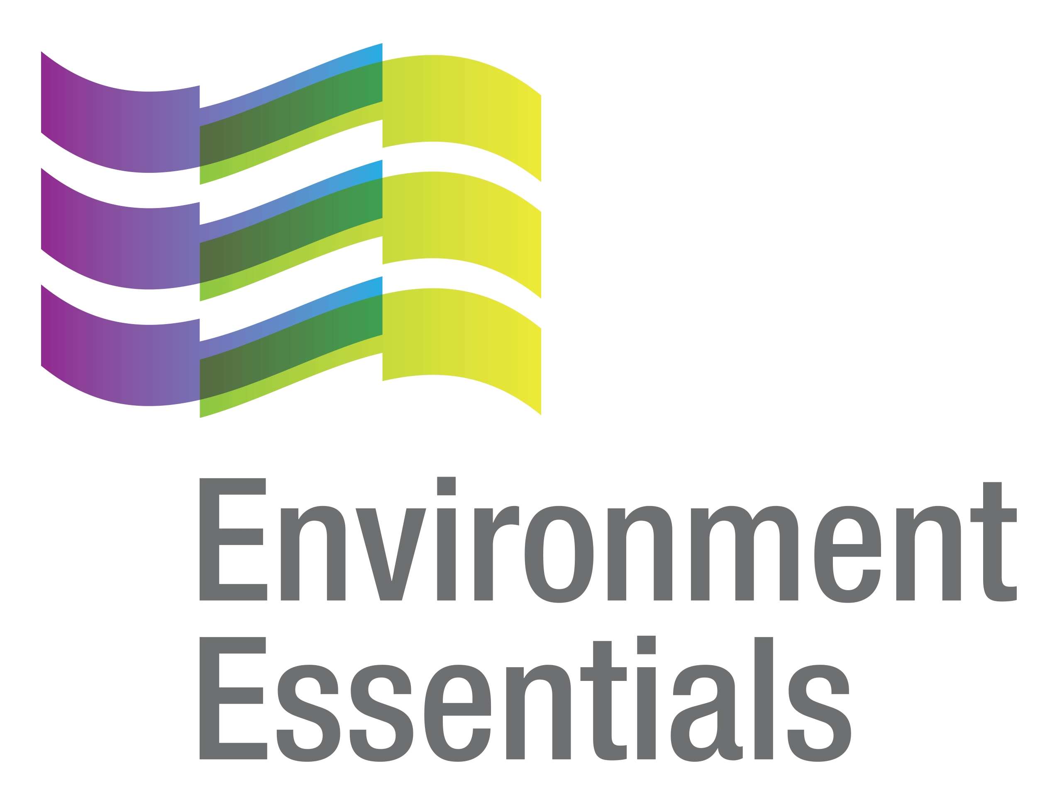 | COVID-19 (Novel Coronavirus)

Wednesday 13 October 2021
Please find below a selection of recent legislation changes relating to COVID-19 and communications for workplaces from key safety and environmental regulators in Australia and New Zealand.
This update is intended to be provided on a weekly basis.
Please note: The legislation in this update was current at time of release. Legislation around COVID-19 is being frequently updated and revoked. The URLs provided may no longer be maintained by the relevant legislation website, after the release date.

Legislation changes

Commonwealth
- Defence Determination, Conditions of service (COVID-19 response - Overseas) Amendment Determination 2021 (No. 21) - Provides bespoke benefits as a consequence of the COVID-19 pandemic for members on duty overseas who are returning to Australia and their pets.

NSW
- Liquor and Gaming Legislation Amendment Regulation 2021 - Amends the Liquor Regulation 2018 to extend by 6 months the period within which specified temporary boundary changes to licensed premises may apply, among other things - came into force on 8 October 2021.
- Order Issued by the Environment Protection Authority Under Section 115(2)(a) of the Pesticides Act 1999 - Exempts, in the circumstances of an emergency, being the current COVID-19 outbreak in NSW, certain classes of persons from Section 39(4) of the Pesticides Act 1999 in relation to the training requirements of Pesticide Control Orders as specified - came into force on 7 October 2021.
- Public Health Amendment (COVID-19 Penalty Notice Offences) Regulation (No 5) 2021 - Updates provisions as a consequence of the repeal of the Public Health (COVID-19 Additional Restrictions for Delta Outbreak) Order (No 2) 2021 by the Public Health (COVID-19 General) Order 2021 - came into force on 11 October 2021.
- Public Health (COVID-19 Additional Restrictions for Delta Outbreak) Order (No 2) Amendment (No 26) Order 2021 - Amends the Public Health (COVID-19 Additional Restrictions for Delta Outbreak) Order (No 2) 2021 to extend the inclusion of certain local government areas and suburbs in the regional NSW area for stay at home areas until 11 October 2021 - came into force on 6 October 2021.
- Public Health (COVID-19 Aged Care Facilities) Amendment Order 2021 - Amends the Public Health (COVID-19 Aged Care Facilities) Order 2021 to limit the number of visitors of residential aged care facilities, and require visitors to be fully vaccinated, unless the visitor is visiting a resident at the end of life - came into force at 9 am on 11 October 2021.
- Public Health (COVID-19 General) Amendment (No 1) Order 2021 - Amends the Public Health (COVID-19 General) Order 2021 to prevent persons from entering or leaving Greater Sydney without a reasonable excuse, prevent unvaccinated adults from undertaking recreation outside the LGAs in which they reside, prevent persons residing in Greater Sydney from undertaking recreation outside Greater Sydney, prevent persons residing outside Greater Sydney from undertaking recreation in Greater Sydney, enable the CHO to identify stay at home areas by a notice published on the NSW Health website, allow certain employees and other workers who reside outside Greater Sydney to work on premises outside Greater Sydney if they have had 1 dose of a COVID-19 vaccine, allow indoor swimming pools to be used in the general area for certain purposes, allow up to 10 persons to visit places of residence and holiday homes in the general area, include additional premises in the general area in which unvaccinated adults must not be present, enable up to 100 persons to attend significant events in the general area, enable up to 30 persons to attend certain outdoor public gatherings in the general area, enable choirs of no more than 10 fully vaccinated persons to perform at places of worship or in a religious services in the general area, remove the exemption from the requirement to wear fitted face coverings in the general area while working at a school, make further provision for the circumstances in which a person under 16 years of age who is not fully vaccinated may be present in higher risk premises in the general area, make it clear the term ‘vehicle’ does not include an aircraft, and to make other amendments in the nature of law revision - came into force on 11 October 2021.

NT
- COVID-19 Directions (No. 54) 2021: Amendment to COVID-19 Directions (No. 38) 2021 - Requires a person prohibited under direction 6 of the COVID-19 Directions (No. 38) 2021 who arrives in the Territory to leave the Territory as soon as possible and, until they leave, comply with Border Directions, unless the person is exempt.

QLD
- Restrictions for Impacted Areas (No. 19) Direction - Requires people living in, or who have been in, or who reside with someone who has been in, an impacted area (Ipswich City Council, Lockyer Valley Regional Council, Noosa Shire Council, Redland City Council, Scenic Rim Regional Council, Somerset Regional Council, Sunshine Coast Regional Council, Brisbane City Council, Gold Coast City Council, Logan City Council and Moreton Bay Regional Council) to wear a face mask.
- Restrictions on Businesses, Activities and Undertakings Direction (No. 29) - Imposes requirements relating to businesses, activities and undertakings, collection of contact information using the Check in QLD App, and provision of contact information, among other things.
- Rural and Regional Adjustment (Further Variation of COVID-19 Business Support Grants Scheme (August 2021)) Amendment Regulation (No. 2) 2021 - Amends the COVID-19 Business Support Grants Scheme (August 2021) further to provide for a one-off $5,000 ongoing hardship grant to certain businesses and non-profit organisations in the ‘border area’ if they have been continuously affected by ‘border closure events’ between 14 August 2021 and 14 October 2021.

SA
- Emergency Management (Activities - Associated Direction No 15) (COVID-19) Direction 2021 - Declares the whole of South Australia to be a declared area that is subject to level 1 restrictions, and modifies the Emergency Management (Activities - General No 3) (COVID-19) Direction 2021 in relation to definitions, density requirements, retail sale or hire, seated food and beverage consumption, gatherings at home, private activities and private functions, among other things.
- Emergency Management (Cross Border Travel - Associated Direction No 57) (COVID-19) Direction 2021 - Applies levels of requirements applying to people arriving from specified restricted zones, modifies the General Direction in its application to certain categories of people, imposes a requirement that most arrivals from high-risk jurisdictions be tested and have commenced being vaccinated against COVID-19, and imposes testing requirements on commercial transport freight workers, including those arriving from zones that are not restricted zones.
- Emergency Management (Healthcare Setting Workers Vaccination) (COVID-19) Direction 2021 - Maintains the provision of healthcare services operating in SA despite the presence of COVID-19 in the community, minimises the disruption to those services due to the spread of COVID-19 amongst healthcare setting workers, minimises the disruption to those services due to workers being furloughed following possible exposure to COVID-19 and reduces the risk of the spread of COVID-19 by healthcare setting workers to patients.

TAS
- Direction Under Section 16 - Contact Tracing - No. 10 - Requires persons to keep specified information for contact tracing and for persons to use the Check in TAS app to record the information required, among other things.
- Direction Under Section 16 - Mandatory Vaccination of Certain Workers - No. 7 - Prohibits persons from entering or remaining on the premises of a residential aged care facility or a quarantine site, or from providing quarantine transport services, unless they are sufficiently vaccinated, and from 31 October 2021, prohibits a person from entering or remaining on the premises of a medical or health care facility, or to provide a health and medical service or treatment, unless the person is sufficiently vaccinated, among other things.
- Payroll Tax (Pandemic) Order 2021 - Waives a relevant business employer from paying payroll tax under the Payroll Tax Act 2008 in respect of the taxable wages paid or payable to each eligible employee, employed in a relevant business of the employer, for the period commencing on 1 July 2021 and ending on 31 December 2021.

VIC
- Area Directions (No. 25) - Identifies areas within Victoria which have a higher prevalence of, or risk of exposure to, COVID-19 and which are subject to specific directions which are reasonably necessary to protect public health - came into force at 11:59 pm on 8 October 2021.
- COVID-19 Mandatory Vaccination (Specified Facilities) Directions (No. 6) - Continues to impose vaccination obligations on operators of residential aged care facilities and construction sites and extends those obligations to operators of healthcare facilities and education facilities - came into force at 11:59 pm on 7 October 2021.
- COVID-19 Mandatory Vaccination (Workers) Directions - Imposes vaccination obligations upon employers in relation to the vaccination of various workers, in order to limit the spread of COVID-19 within the population of these workers - came into force at 11:59 pm on 7 October 2021.
- COVID-19 Vaccinated Activities Directions (No. 3) - Imposes certain mandatory vaccination requirements in order for specific businesses (outdoor personal training in the restricted area and theatres in the Restricted Area and Regional Victoria) to provide goods or services to the public to limit the spread of COVID-19 within the population in these settings - came into force at 11:59 pm on 9 October 2021.
- Restricted Activity Directions (Regional Victoria) (No. 14) - Restricts the operation of certain businesses and undertakings in Regional Victoria to address the serious public health risk posed to Victoria by COVID-19 - came into force at 11:59 pm on 9 October 2021.
- Restricted Activity Directions (Restricted Areas) (No. 21) - Restricts the operation of certain businesses and undertakings in the restricted area to address the serious public health risk posed to Victoria by COVID-19 - came into force at 11:59 pm on 9 October 2021.
- Stay at Home Directions (Restricted Areas) (No. 28) - Requires everyone in the restricted area to limit their interaction with others by restricting the circumstances in which they may leave the premises where they ordinarily reside, restricting public and private gatherings, including prohibiting visitors to another person’s home other than in limited circumstances, and requiring face covering to be worn indoors and outdoors - came into force at 11:59 pm on 9 October 2021.
- Stay Safe Directions (Regional Victoria) (No. 13) - Requires everyone who ordinarily resides in Regional Victoria to restrict the circumstances in which they may leave Regional Victoria, limit interactions with other by restricting private and public gatherings and carry and wear face coverings at all times except in limited circumstances - came into force at 11:59 pm on 9 October 2021.
- Workplace (Additional Industry Obligations) Directions (No. 50) - Establishes additional specific obligations on employers and workers in specific industries in relation to managing the risk associated with COVID-19 - came into force at 11:59 pm on 8 October 2021.

WA

Extension of State of Emergency Declaration - Extends the state of emergency declaration for a period of 14 days.

NZ
- COVID-19 Public Health Response (Alert Level Requirements) Order (No 12) Amendment Order (No 5) 2021 - Amends the COVID-19 Public Health Response (Alert Level Requirements) Order (No 12) 2021 in relation to travelling through the Auckland part of the alert level 3 area to go to work in the Waikato part of the alert level 3 area, adding the New Zealand Police to the list of businesses or services in Clause 23(1) of the Order, removing the description of the list of in-home services in Clause 29 to clarify that the clause only applies to those services, adding lifesaving and search and rescue services provided by the Royal New Zealand Coastguard and Surf Life Saving New Zealand, and workers carrying out those services, to the list of exemptions in Clause 53, adding legal services to execute documents to the list of permitted in-home services, and adjusting the description of the Waikato part of the alert level 3 area to include the Waipa, Ōtorohanga and Waitomo districts, among other things.

C

From the regulators

Australia

Australian Government:

Press Conference - Canberra, ACT
  - Remarks the Lodge Canberra, ACT

Department of Health:
  - ATAGI Update Following Weekly COVID-19 Meeting - 6 October 2021
  - COVID-19 Vaccination Information Kiosks Now Open in Qld and WA
  - Hotspot Declared for the Rural City of Mildura, Victoria
  - Hotspot for the Purposes of Commonwealth Support Extended for Greater Melbourne, And Mitchell Shire
  - Hotspot for the Purposes of Commonwealth Support Extended for NSW and Jervis Bay
  - Third Dose of COVID-19 Vaccine Recommended for People Who are Severely Immunocompromised
  - Top 3 COVID-19 Vaccine Questions - COVID-19 Vaccines for Over 60s, Fertility, and Transmission from Children
  - Updated Advice on Requirements for Workers in Health Care Settings Who are Exposed to COVID-19

ACT

ACT Government:
  - Additional COVID-19 Vaccines
  - Lockdown in the ACT
  - Supporting Hospitality Recovery with Outdoor Dining Expansion

NSW

NSW Government:
  - Changes to Public Health Orders for NSW Residents Who Enter ACT for Work or Medical Care
  - Changes to Stay-At-Home Orders for Regional NSW Local Government Areas
  - Confidence Guaranteed as We Get Back to Work
  - New Hardship Panel to Provide More Businesses with COVID-19 Financial Support
  - NSW Freedoms Never Tasted So Sweet
  - NSW Ministry to Deliver Safe, Strong Recovery
  - NSW On the Road to Reopening
  - Ready, Set, Go: NSW Prepares to Re-Open
  - Regional Pilot Locations for COVID-19 Digital Certificates Announced
  - Regional Racing Back on Track
  - Regional Travel Just Weeks Away

NT

NT Government:
  - Check Exposure Sites and Monitor Symptoms for Tasmania
  - Darwin Secures Direct London Flights
  - More Support for Territory Businesses
  - Territory to Surpass 80% Vaccination Milestone This Week

SA

SA Government:
  - FAQ: Mandatory COVID-19 Vaccination for People Working in Public and Private Hospitals
  - Further Support for South East Businesses Impacted By COVID-19
  - SA’s Recovery Goes from ‘Strength to Strength’: Deloitte
  - Vaccination Vans to Hit SA Roads
  - Victorian Essential Travellers Table

TAS

Tasmanian Government:
  - ATAGI Advice for Third Vaccine Dose
  - Check in TAS Technical Issues
  - Deloitte Access Economics Report Confirms Our Plan is Working
  - Important Community Updates
  - Reminding Tasmanian Businesses to Get Their Critical Support Grant Applications Completed
  - Testing of Contacts and Community to Continue

VIC
- Department of Health and Human Services:
  - Coronavirus Update for Victoria - 8 October 2021
  - Coronavirus Update for Victoria - 9 October 2021
  - Lockdown Restrictions in Moorabool to Lift Tonight - 8 October 2021
  - Lockdown Restrictions in Shepparton to Lift Tonight - 8 October 2021
  - Mildura to Enter Seven-day Lockdown Tonight - 8 October 2021
- VIC Government:
  - More than Two Million Rapid Antigen Tests on the Way
  - Open Access for All Victorians Above 12 for mRNA Vaccines
  - Supporting Families Experiencing Anxiety
  - Supporting Our Senior Vocational Education Students
  - Targeted Support for Creative Workers and Organisations
  - Vaccinated Economy - At the Cup, the Bowl and the Movies
  - Vaccination Boost for People Living with a Disability
  - Victoria Sets Plan to Welcome Back International Students

WorkSafe VIC: Accommodation Provider Charged for Alleged COVID-19 Breach

WA

Department of Health: School-Based COVID-19 Vaccination Underway this Week for Students

Department of Mines, Industry Regulation and Safety: WA Resources Sector’s Biggest Year Ever Powering Nation Through COVID
- WA Government:
  - Mandatory COVID-19 Vaccines for Primary and Community Health Workers
  - Mandatory Vaccinations for Dunsborough School Leavers Event
  - Public Health Advice Issued for Western Australians
  - Roll Up for WA at New and Expanded COVID-19 Vaccination Clinics

NZ

NZ Government:
  - Big Vaccination Drive Leading to a National Day of Action on October 16
  - Dedicated Team to Support Disabled People to Access COVID-19 Vaccine
  - Extension of Alert Level 3 Boundary in Waikato
  - Firearms Licence Extensions Granted to Those Affected by COVID-19 Delays
  - Fund Allows More Pacific Community Led Vaccinations
  - Government Provides Certainty to Working Holiday and Seasonal Visa Holders and Employers for Summer
  - Government to Pilot Antigen Testing with Private Sector
  - Mandatory Vaccination for Two Workforces
  - More Support for Business Available from Today
  - Northland to Move to Alert Level 3 Tonight
  - Record Day for Māori Vaccinations
  - Small Business at Heart of Economic Recovery Across APEC Region

Other
- World Health Organisation:
  - WHO Report Highlights Global Shortfall in Investment in Mental Health
  - WHO, UN Set Out Steps to Meet World COVID Vaccination Targets

That completes this edition of the COVID-19 update. The next update will be released on Wednesday 20 October 2021.

Environment Essentials Pty Ltd ǀ ABN: 29 103 207 638
A Suite 8 / 8 Clay Drive, Doncaster Vic 3108, Australia ǀ T +61 3 9095 6533
W www.enviroessentials.com.au

