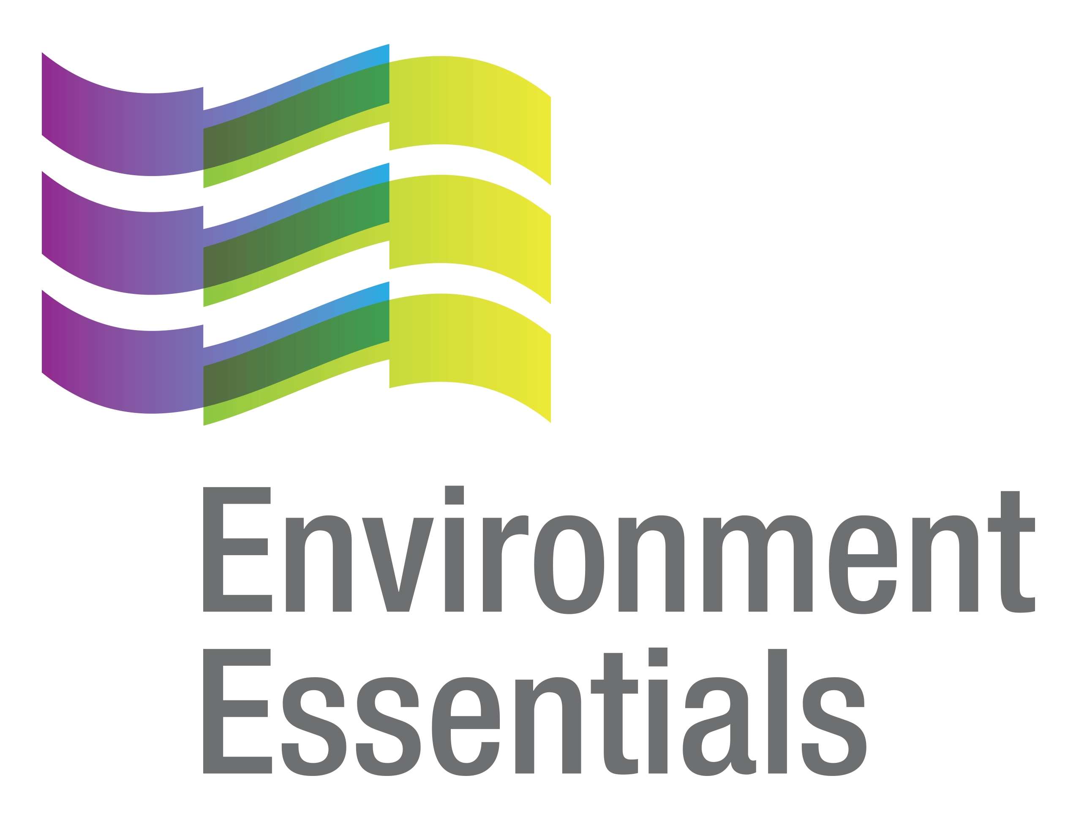 | COVID-19 (Novel Coronavirus)

Wednesday 21 July 2021
Please find below a selection of recent legislation changes relating to COVID-19 and communications for workplaces from key safety and environmental regulators in Australia and New Zealand.
This update is intended to be provided on a weekly basis.
Please note: The legislation in this update was current at time of release. Legislation around COVID-19 is being frequently updated and revoked. The URLs provided may no longer be maintained by the relevant legislation website, after the release date.

Legislation changes

Commonwealth

Childcare Subsidy Amendment (Coronavirus Response Measures - New South Wales) Minister’s Rules 2021 - Amends the Child Care Subsidy Minister’s Rules 2017 to introduce measures to support approved child care providers and families in New South Wales subject to “stay at home” restrictions in response to the COVID-19 pandemic, including allowing approved providers to waive their fees for child care services during the period the “stay at home” restrictions apply.
- Income Tax Assessment (Eligible State and Territory COVID-19 Economic Recovery Grant Programs) Amendment Declaration (No. 1) 2021 - Declares grant programs administered by the State of Victoria as eligible programs for the purposes of Section 59-97 of the Income Tax Assessment Act 1997, under which a payment received by a small business entity from an eligible program is non‑assessable non-exempt income.

ACT

Public Health (Check In Requirements) Emergency Direction 2021 (No 2) - Limits the spread of COVID-19 by requiring reliable attendance records, which enable rapid and effective contract tracing.

NSW

Poisons and Therapeutic Goods Regulation 2008 - Approval (14 July 2021) - Revokes the approval instrument signed on 26 June 2021 and approves the SARS-CoV-2 (COVID-19) AstraZeneca (ChAdOx1-S) for the purposes of Clause 48A(1A)(d) of the Poisons and Therapeutic Goods Regulation 2008 regarding the supply by pharmacists of certain vaccines and Section 43 of the Interpretation Act 1987, subject to the specified conditions - came into force on 16 July 2021.

Public Health (COVID-19 Temporary Movement and Gathering Restrictions) Amendment (No 7) Order 2021
- Extends the operation of the Public Health (COVID-19 Temporary Movement and Gathering Restrictions) Order 2021 until 31 July 2021 - came into force on 16 July 2021.

Public Health (COVID-19 Temporary Movement and Gathering Restrictions) Amendment (No 8) Order 2021 - Amends the Public Health (COVID-19 Temporary Movement and Gathering Restrictions) Order 2021 to, among other things, insert various definitions, direct that an employer must require an employee to work at home, require people to wear a fitted mask in various outdoor settings and to carry a mask at all times, prohibit specified trades persons and cleaners from visiting places of residence in Greater Sydney and directs the closure of certain premises including some retail premises and the closure of construction sites - came into force on 18 July 2021 and 19 July 2021.

Public Health (COVID-19 Temporary Movement and Gathering Restrictions) Amendment (No 9) Order 2021 - Amends the Public Health (COVID-19 Temporary Movement and Gathering Restrictions) Order 2021 to, among other things, change the definition of “Construction Site” to include a place at which civil works are being carried out and lowers the age at which a person who is driving a vehicle in Greater Sydney must carry required evidence of place of residence from 18 years of age to 16 years of age - came into force on 18 July 2021 and 19 July 2021.
- Public Health (COVID-19 Temporary Movement and Gathering Restrictions) Amendment (No 10) Order 2021 - Amends the Public Health (COVID-19 Temporary Movement and Gathering Restrictions) Order 2021 in relation to working from home and exemptions for visitor restrictions, among other things.
- Public Health (COVID-19 Temporary Movement and Gathering Restrictions) Amendment (No 11) Order 2021 - Establishes special directions for regional NSW, including the regions of Blayney, Cabonne and the City of Orange, among other things.
- Residential Tenancies (COVID-19 Pandemic Emergency Response) Amendment Regulation 2021 - Exempts tenants who are financially impacted by the COVID-19 pandemic from the operation of provisions of the Residential Tenancies Act 2010 or the regulations made under that Act that would result in the termination of residential tenancy agreements or the recovery of possession of the premises on the grounds of non-payment of rent or charges if the tenants continue to pay at least 25% of the rent payable under the agreement - came into force on 14 July 2021.
- Retail and Other Commercial Leases (COVID-19) Regulation 2021 - Limits the exercise of rights of certain by lessors under retail and certain other commercial leases for a breach of the lease - came into force on 14 July 2021.

QLD
- Border Restrictions Direction (No. 27) - Sets the requirements for entry into Queensland from COVID-19 hotspots.
- Declared Hotspots Direction - Identifies COVID-19 hotspots for Public Health Direction - Border Restrictions Direction (No. 27) or its successor, identifies COVID-19 hotspots for other public health directions about the movement of people to or from COVID-19 hotspots and declares the 79 LGA’s and 10 unincorporated areas of Victoria as COVID-19 hotspots.
- Queensland COVID-19 Restricted Areas (No. 17) - Identifies Queensland COVID-19 restricted areas for the Public Health Direction - Residential Aged Care Direction (No. 2), Public Health Direction - Disability Accommodation Services (No. 20), Public Health Direction - Hospital Entry or their successors.
- Queensland Travel Declaration Direction (No. 4) - Directs, among other things, specified persons entering Queensland to complete a Queensland Travel Declaration within the specified time period and to monitor interstate exposure venues at least once every 24 hours from the time the declaration was completed and for 14 days after arrival in Queensland.
- Restrictions for Impacted Areas Direction (No. 9) - Restricts the number of people who may gather in homes or public places in an impacted area and how certain businesses must operate within the impacted areas.
- Restrictions on Businesses, Activities and Undertakings Direction (No. 22) - Restricts the operation of certain businesses, activities or undertakings and requires collection and provision of contact information, among other things.

SA
- Emergency Management (Activities - General No 2) (COVID-19) Direction 2021 - Implements a range of basic control measures applying to public activities and gatherings while the Major Emergency is in force, and allows for other levels of control measures to be put in place by associated directions where necessary.
- Emergency Management (Activities - Associated Direction No 3) (COVID-19) Direction 2021 - Declares the whole of South Australia to be a declared area that is subject to level 5 restrictions.
- Emergency Management (Cross Border Travel - Associated Direction No 33) (COVID-19) Direction 2021 - Declares the ACT, NSW, Greater Brisbane and Victoria as restricted zones and imposes border requirements on certain interstate arrivals and overseas arrivals, among other things.

Emergency Management (Public Activities No 29) (COVID-19) Direction 2021 - Imposes principles and rules relating to the conduct of certain activities involving members of the public, the management of places in which said activities occur, and the management of contract tracing records in relation to the COVID-19 outbreak within SA.
- Emergency Management (Residential Aged Care Facilities No 39) (COVID-19) Direction 2021 - Ensures appropriate measures are taken to establish controls and safeguards to protect vulnerable members of the South Australian community, including by mandating a requirement to maintain records of COVID-19 vaccinations.

TAS

Direction Under Section 16 - Contact Tracing - No. 7 - Requires persons to use the Check in TAS app when entering a relevant location and for owners or operators of a relevant location to ensure that a QR code that is compatible with the Check in TAS app is displayed and keep specified information.

Direction Under Section 16 - Travellers from Victoria No. 2 - Requires certain people in Tasmania who were in Victoria within the specified date and time to wear a fitted face covering in certain situations.

VIC

Care Facilities Directions (No. 37) - Makes provision for restricted access to care facilities to limit the spread of COVID-19 within a particularly vulnerable population - came into force at 11.59 pm 20 July 2021.
- Hospital Visitor Directions (No. 33) - Prohibits certain visits to hospitals in order to limit the spread of COVID-19 - came into force at 11.59 pm 20 July 2021.
- Restricted Activity Directions (Victoria) (No. 19) - Restricts the operation of certain businesses and undertakings in the State of Victoria to address the serious public health risk posed by COVID-19 - came into force at 11.59 pm 20 July 2021.
- Stay at Home Directions (Victoria) (No. 3) - Requires Victorians to limit their interactions with others by restricting the circumstances in which they may leave their residence, restricting public and private gatherings including prohibiting visitors to their homes and requiring face coverings to be worn indoors and outdoors - came into force at 11.59 pm 20 July 2021.
- Victorian Border Crossing Permit Directions (No. 23) - Provides a ‘traffic light’ border crossing scheme for persons seeking to enter Victoria from another State or Territory in Australia, or after entering Australia from a Green Zone Country in order to limit the spread of COVID-19 - came into force at 11.59 pm 20 July 2021.
- Workplace (Additional Industry Obligations) Directions (No. 33) - Establishes additional specific obligations on employers and workers in specific industries in relation to managing the risk associated with COVID-19 - came into force at 11.59 pm 15 July 2021.
- Workplace Directions (No. 38) - Limits the number of Victorians attending Work Premises to assist in reducing the frequency and scale of COVID-19 outbreaks in Victorian workplaces and establishes more specific obligations on employers and workers in relation to managing the risk associated with COVID-19 - came into force at 11.59 pm 20 July 2021.

WA

Controlled Border for Western Australia Amendment Directions (No 33) - Amends the Controlled Border for Western Australia Directions to add Victoria as an ‘outbreak jurisdiction’.

Extension of State of Emergency Declaration - Extends the state of emergency declaration made on 15 March 2020 for fourteen days.

Outbreak Outside of Western Australia Response Directions (No 2) - Helps prevent the importation of COVID-19 into WA following an outbreak of COVID-19 outside of WA, and to otherwise limit the spread of COVID-19.

Presentation for Testing Directions (No 28) - Prevents the importation of COVID-19 into WA and to otherwise limits the spread of COVID-19.

Public Health Amendment Regulations (No. 2) 2021 - Amends the Public Health Regulations 2017 to include, among other diseases, ‘human coronavirus with pandemic potential’ to the table of notifiable infectious diseases.
- South Australia Exposure Site Directions - Helps prevent the importation of COVID-19 into Western Australia following recent potential community exposure to COVID-19 in the South Australian community and otherwise limits the spread of COVID-19 in Western Australia.
- Victoria Exposure Site Directions - Helps prevent the importation of COVID-19 into Western Australia following recent potential community exposure to COVID-19 in the Victorian community and otherwise limits the spread of COVID-19 in Western Australia.

NZ
- COVID-19 Public Health Response (Exemptions and Conditions for Quarantine-free Travel) Amendment Notice (No 11) 2021 - Expands the condition that a person must not have been in the State of New South Wales at or after 10:30 pm on 26 June 2021 (New Zealand time) so that a person also must not have been in the State of Victoria at or after 1:59 am on 16 July 2021.
- COVID-19 Public Health Response (Exemptions and Conditions for Quarantine-free Travel) Amendment Notice (No 12) 2021 - Enables a person who was in New South Wales or Victoria at or after the specified time to return on a QFT flight, provided that they have not been in either State within the 14-day period before the scheduled departure of their QFT flight (and they comply with the other applicable conditions in the principal notice).

j

From the regulators

Australia
- Therapeutic Goods Administration: COVID-19 Vaccine Advertising and Import Compliance

ACT

ACT Government:
  - Check In CBR Expands to Public Transport and all Retail Settings
  - Entering the ACT
  - New Exposure Locations in South Australia
  - Stay-at-Home Order for Travellers from Victoria
  - Work to Begin Expanding COVID Vaccine Eligibility

NSW

NSW Government:

Central West Restrictions

Lockdown Extended to 30 July 2021
  - Lockdown Lifeline - Mental Health Support Package for NSW
- SafeWork NSW: Increased Compliance Operations for COVID Safe Workplaces

NT

NT Government:

COVID-19 Update: Bass Coast in Victoria Declared a Hotspot

COVID-19 Update: Hotspots Declared Across Parts of Victoria

Mildura in Victoria Declared as a Hotspot
  - South Australia Public Exposure Site Testing and Quarantine Directions

QLD

Queensland Government: Restrictions for Impacted Areas - South East Queensland

SA
- SA Government:
  - Cross Border Travel - Associated Direction Essential Traveller Table - Greater Brisbane, ACT and NSW Essential Travellers
  - Cross Border Travel - Associated Direction Essential Traveller Table - Victorian Essential Travellers
  - Half a Million South Australians have Received First Vaccine
  - Level 5 Restrictions
  - Public Activities Chart
  - Public Activities Chart - Level 5 Requirements - List of Essential Workers
  - Public Activities Chart - Level 5 Requirements - Stay at Home Restrictions

TAS
- TAS Government:
  - Check in to Keep Tasmania Open for Business
  - Continuing to Keep Our Community Safe from COVID-19
  - COVID-19 Update - South Australia
  - COVID-19 Update - Victoria
  - Dedicated COVID-19 Response Team Established within Worksafe Tasmania
  - Important Community Updates
  - Mask Wearing in Schools
  - New Requirements for Recent Travellers from Victoria
  - New South Wales Update
  - Thank You for Following Return to School Advice

VIC

Maritime Safety Victoria: Response to Boating Queries About Coronavirus (COVID-19)

VIC Government:
  - Cash Support for Victorian Businesses During Lockdown
  - Extended Lockdown and Stronger Borders to Keep Us Safe
  - Statement from the Premier

WA

Department of Health:

COVID-19 Update 19 July 2021 - BBC California Vessel

COVID-19 Update 19 July 2021 - New WA Health Advice in Relation to South Australia

WA Government:
  - Exemptions Tightened for Travellers from NSW
  - New Public Health Advice Issued for South Australia
  - WA Introduces Hard Border with Victoria

NZ

Ministry of Health:

COVID-19 Testing Infringement Notices Issued to Border Workers

Pause on Quarantine-Free Travel from Victoria Extended; QFT with Queensland Continues
  - Playa Zahara Update
  - Update on Whole Genome Sequencing for Playa Zahara

NZ Government:
  - Applications for Urgent Travel from New South Wales to New Zealand
  - Boost for Pacific Regional Business
  - Early Pfizer Shipment Boosts Vaccine Schedule
  - Extended Essential Skills Visas being Rolled Out
  - Further Advice Being Sought on New Cases in Victoria
  - Pause to Quarantine Free Travel from Victoria to New Zealand
  - PM Ardern Call with President Biden
  - PM Ardern Chairs APEC Leaders’ Meeting on COVID-19
  - Saliva Testing Expansion for Frontline Border Workers
  - Tourism Support Package Continues to Rollout
  - Urgent Applications to be Prioritised for a Second Release of Rooms in MIQ

Other
- World Health Organisation:
  - Statement on the Eighth Meeting of the International Health Regulations (2005) Emergency Committee Regarding the Coronavirus Disease (COVID-19) Pandemic
  - Updated WHO SAGE Roadmap for Prioritizing Uses of COVID-19 Vaccines in the Context of Limited Supply

That completes this edition of the COVID-19 update. The next update will be released on Wednesday 28 July 2021.

Environment Essentials Pty Ltd ǀ ABN: 29 103 207 638
A Suite 8 / 8 Clay Drive, Doncaster Vic 3108, Australia ǀ T +61 3 9095 6533
W www.enviroessentials.com.au

