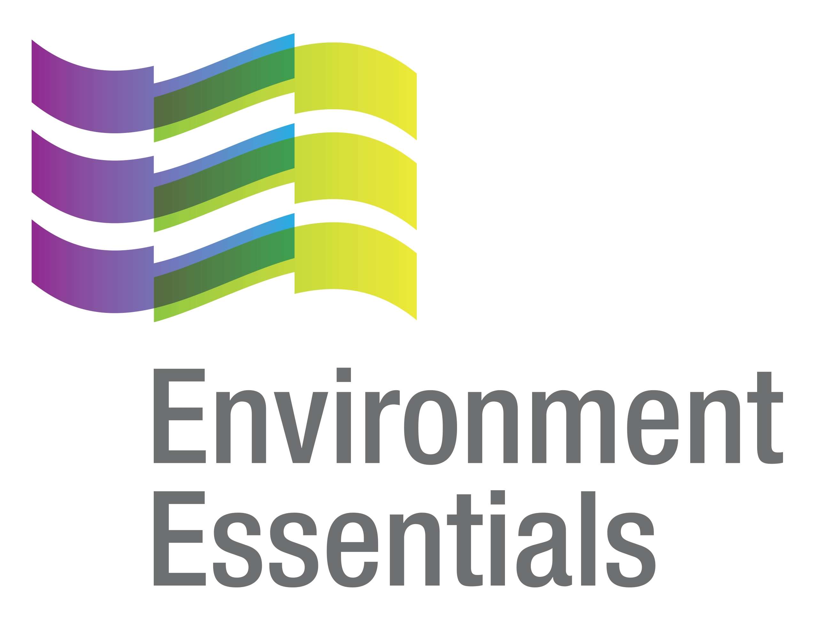 | COVID-19 (Novel Coronavirus)

Wednesday 9 June 2021
Please find below a selection of recent legislation changes relating to COVID-19 and communications for workplaces from key safety and environmental regulators in Australia and New Zealand.
This update is intended to be provided on a weekly basis.
Please note: The legislation in this update was current at time of release. Legislation around COVID-19 is being frequently updated and revoked. The URLs provided may no longer be maintained by the relevant legislation website, after the release date.

Legislation changes

Commonwealth

Aged Care Legislation Amendment (Service Staff Vaccination Recording and Reporting) Principles 2021 - Establishes requirements on certain approved providers to keep records of service staff who have voluntarily disclosed their COVID-19 vaccination status and report the number of staff vaccinated against COVID-19 and influenza to the Secretary.

Defence Determination, Conditions of service Amendment (Assisted Leave Travel) Determination 2021 (No. 8) - Amends the Defence Determination 2016/19 to enable members on long-term posting overseas to use existing assisted leave travel benefit within their country of posting.
- Financial Framework (Supplementary Powers) Amendment (Home Affairs Measures No. 2) Regulations 2021 - Amends the Financial Framework (Supplementary Powers) Regulations 1997 to establish legislative authority for government spending on the COVID-19 Disaster Payment, which will provide one-off and time-limited financial assistance to certain eligible workers.
- Financial Framework (Supplementary Powers) Amendment (Home Affairs Measures No. 3) Regulations 2021 - Amends table item 492 in Part 4 of Schedule 1AB to the Financial Framework (Supplementary Powers) Regulations 1997, which establishes legislative authority for government spending on the COVID-19 Disaster Payment.
- Therapeutic Goods Amendment (Therapeutic Goods Advertising Code) Instrument 2021 - Amends the Therapeutic Goods Advertising Code (No.2) 2018 to supplement the kinds of advertisements in which it does not apply to include an advertisement which is made in accordance with the Therapeutic Goods (Restricted Representations - COVID-19 Vaccines) Permission 2021, as in force or existing on 5 June 2021.

ACT
- Public Health (COVID-19 Affected Areas) Emergency Direction 2021 (No 8) - Requires affected persons who are residents of the ACT to undertake quarantine and complete a self-declaration form, prohibits certain affected persons who are not residents of the ACT from entering the ACT without an exemption, and imposes stay-at-home requirements on persons who have been in certain affected areas, among other things.
- Public Health (Residential Aged Care Facilities) Emergency Direction 2021 (No 4) - Provides for restricted access to residential aged care facilities in order to limit the spread of COVID-19 within a particularly vulnerable population.
- Public Health (Returned Travellers) Emergency Direction 2021 - Requires persons to quarantine following overseas travel, and requires international flight crew, air ambulance and medevac crew to self-quarantine upon arrival in the ACT.

NSW
- Public Health (COVID-19 Air Transportation Quarantine) Order (No 2) 2021 - Repeals and remakes, with some changes, the Public Health (COVID-19 Air Transportation Quarantine) Order 2021.
- Public Health (COVID-19 Gathering Restrictions) Order (No. 2) 2021 - Repeals and remakes, with minor changes, the Public Health (COVID-19 Gathering Restrictions) Order 2021.
- Public Health (COVID-19 Maritime Quarantine) Order (No 2) 2021 - Repeals and remakes, with some changes, the Public Health (COVID-19 Maritime Quarantine) Order 2021.

QLD

Places of Concern Direction (No. 4) - Requires persons who have been in a place of concern to quarantine, wear a fitted mask and provide information to an emergency officer as requested.

VIC

Area Directions (No. 10) - Identifies areas within Victoria which have a higher prevalence of, or risk of exposure to, COVID-19 and which are subject to specific directions - came into force at 11.59 pm 3 June 2021.
- Care Facilities Directions (No. 31) - Provides for restricted access to care facilities in order to limit the spread of COVID-19 within a particularly vulnerable population - came into force at 11.59 pm 3 June 2021.
- Diagnosed Persons and Close Contacts Directions (No. 23) - Requires persons diagnosed with COVID-19 to self-isolate, and persons living with a diagnosed person who have been in close contact with that person to self-quarantine - came into force at 11.59 pm 3 June 2021.
- Extension of Declaration of a State of Emergency - Further extends the Declaration of a state of emergency made on 16 March 2020 until 11:59 pm on 1 July 2021.
- Hospital Visitor Directions (No. 27) - Prohibits non-essential visits and access to hospitals in order to limit the spread of COVID-19 within a particularly vulnerable population - came into force at 11.59 pm 3 June 2021.
- Restricted Activity Directions (Metropolitan Melbourne) - Restricts the operation of certain businesses and undertakings in Metropolitan Melbourne - came into force at 11.59 pm 3 June 2021.
- Restricted Activity Directions (Regional Victoria) - Restricts the operation of certain businesses and undertakings in Regional Victoria - came into force at 11.59 pm 3 June 2021.
- Stay at Home Directions (Metropolitan Melbourne) - Requires residents of Metropolitan Melbourne to limit their interaction with others by restricting circumstances in which they may leave the residence, restricting private and public gatherings and requiring face coverings to be worn indoors and outdoors - came into force at 11.59 pm 3 June 2021.
- Stay Safe Directions (Regional Victoria) - Restricts circumstances in which residents of Regional Victoria may leave Regional Victoria, and imposes requirements on such residents that limit private and public gatherings and require face coverings to be carried and worn - came into force at 11.59 pm 3 June 2021.
- Victorian Border Crossing Permit Directions (No. 15) - Replaces the Victorian Border Crossing Permit Directions (No 14) and continues to provide a ‘traffic light’ border crossing scheme for persons seeking to enter Victoria from any other State or Territory in Australia or, after entering Australia from a Green Zone Country in order to limit the spread of COVID-19 - came into force at 11.59 pm 3 June 2021.
- Workplace (Additional Industry Obligations) Directions (No. 26) - Establishes additional specific obligations on employers and workers in specific industries in relation to managing the risk associated with COVID-19 - came into force at 11.59 pm 3 June 2021.
- Workplace Directions (No. 31) - Limits the number of Victorians attending Work Premises to assist in reducing the frequency and scale of COVID-19 outbreaks in Victorian workplaces and to establish more specific obligations on employers and workers in relation to managing the risk associated with COVID-19 - came into force at 11.59 pm 3 June 2021.

WA

COVID-19 Response Legislation Amendment (Extension of Expiring Provisions) Act 2021 - Amends The Criminal Code, and the Criminal Code Amendment (COVID-19 Response) Act 2020 and Emergency Management Amendment (COVID-19 Response) Act 2020, to extend the operation of certain provisions related to the COVID-19 pandemic.

Local Government (COVID-19 Response) Amendment Order 2021 - Amends clause 3(1), 8, 13 and 14 of the Local Government (COVID-19 Response) Order 2020 relating to budgets and financial years.

NZ
- COVID-19 Public Health Response (Air Border) Order (No 2) Amendment Order (No 4) 2021 - Among other things, amends the COVID-19 Public Health Response (Air Border) Order (No 2) 2020 to make Air Chathams Limited a QFT carrier for the purposes of quarantine-free travel flights (or QFT flights) that depart from international airports in Australia at or after the commencement time.
- COVID-19 Public Health Response (Exemptions and Conditions for Quarantine-free Travel) Amendment Notice (No 3) 2021 - Alters conditions imposed on persons exempt under the COVID-19 Public Health Response (Exemptions and Conditions for Quarantine-free Travel) Notice 2021 from certain isolation or quarantine requirements.
- COVID-19 Public Health Response (Required Testing) Amendment Order (No 2) 2021 - Adds health workers to the groups of affected persons who are required to undergo testing and medical examination at least once every 7 days.

From the regulators

Australia

Australian Government:

Extending COVID-19 Vaccine Access for Our Region

National Cabinet Statement - 04 Jun 2021
- Therapeutic Goods Administration:
  - Misleading Radio Messages about COVID-19 Vaccine Safety
  - New Regulatory Arrangements Support Businesses and Health Professionals to Communicate and Incentivise COVID-19 Vaccination
  - V P & Associates Pty Ltd Fined $26,640 for Alleged Unlawful Advertising of Liquim in Relation to SARS-CoV-2 Coronavirus

ACT

ACT Government:
  - ACT Travel Requirements for NSW Exposure Locations
  - Latest News - COVID-19 Vaccine
  - New COVID-19 Exposure Locations in NSW
  - Update on ACT Travel Requirements from New South Wales and Victoria

NSW

NSW Health:

NSW Spearheads Key COVID-19 Vaccine Research
  - Public Health Alert- Advice for People Who Have Been in Victoria Since 4pm 27 May

NT

NT Government:

CHO Direction: Day 17 Quarantine Testing Requirement
  - Millions of Check-Ins Across the Territory

Over 16’s Eligible for COVID-19 Vaccine

State of Victoria Declared a Hotspot

QLD

Queensland Government:

Deputy Commissioner Heads Vaccination Roll-Out
  - Massive Expansion for Qld Vaccination Effort

SA
- SA Government: Vaccine Rollout Realigned to Protect Residential Aged Care Facilities

TAS
- Tasmanian Government:
  - COVID-19 Update: NSW High-risk Locations
  - More Tasmanians to be Eligible for a COVID-19 Vaccination
  - Update on Victoria
  - Update to COVID-19 Vaccine Roll Out
  - Victoria COVID-19 Update
  - Victoria Travel Restrictions

VIC

Victorian Government:
  - Coronavirus Restrictions to Lift for Regional Victoria
  - Keeping Workplaces Safe and Supporting Businesses
  - Restrictions from 11.59PM Thursday 10 June
  - Statement from the Acting Premier - 9 June 2021

WA

Department of Health: COVID-19 Update 2 June 2021: WA Health Directions in Relation to NSW and ACT

WA Government:

Cautious Approach Being Taken to Ensure Community Safety

Health Advice about Previous Positive COVID-19 Case

NZ

NZ Government:

APEC Trade Ministers’ Unite on COVID-19 Vaccine Steps and Rejuvenating the WTO

Quarantine Free Travel Pause with Victoria to Continue, Planning Underway for Managed Return Flights

Other
- Standards Australia: New Guidance for Respiratory Protective Equipment Released

A
That completes this edition of the COVID-19 update. The next update will be released on Wednesday 16 June 2021.

Environment Essentials Pty Ltd ǀ ABN: 29 103 207 638
A Suite 8 / 8 Clay Drive, Doncaster Vic 3108, Australia ǀ T +61 3 9095 6533
W www.enviroessentials.com.au

