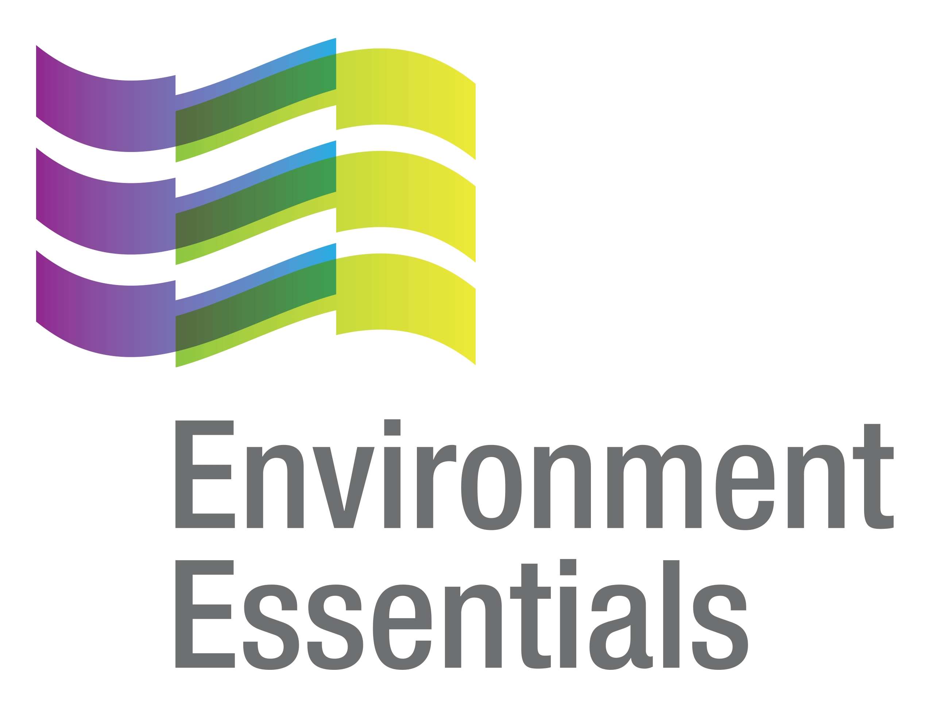 | COVID-19 (Novel Coronavirus)

Wednesday 12 May 2021
Please find below a selection of recent legislation changes relating to COVID-19 and communications for workplaces from key safety and environmental regulators in Australia and New Zealand.
This update is intended to be provided on a weekly basis.
Please note: The legislation in this update was current at time of release. Legislation around COVID-19 is being frequently updated and revoked. The URLs provided may no longer be maintained by the relevant legislation website, after the release date.

Legislation changes

Commonwealth
- Child Support (Assessment) (AWE Amount) Determination 2021 - Determines an approximate Average Weekly Earnings amount to ensure children of separated parents continue to share appropriately in the standards of living of their parents in line with the intent of the child support policy, notwithstanding the extraordinary circumstances that have arisen due to the COVID19 pandemic.

NSW

Environmental Planning and Assessment (COVID-19 Development - Construction Work Days) Order (No 1) 2021 - Revokes the Environmental Planning and Assessment (COVID-19 Development - Construction Work Days) Order 2020, returning construction work days and hours to their pre-pandemic settings.
- Public Health (COVID-19 Gathering Restrictions) Amendment Order (Exemptions) 2021 - Amends the Public Health (COVID-19 Gathering Restrictions) Order 2021 to provide that the Minister may not grant an exemption from the requirement in Clause 26A of the Order that contact details provided under Clause 25 may be used only for the purposes of contact tracing during the COVID-19 pandemic.
- Public Health (COVID-19 Greater Sydney) Amendment Order 2021 - Extends the operation of the Public Health (COVID-19 Greater Sydney) Order 2021, with minor changes, for 7 days.
- Public Health (COVID-19 Greater Sydney) Order 2021 - Responds to a case of community transmission of COVID-19 by placing certain restrictions on gathering in the Greater Sydney area.
- Public Health (COVID-19 Interstate Travellers) Order (No 2) 2021 - Enables the Chief Health Officer to identify places outside of NSW as affected areas, areas of concern and places of high concern, and requires persons arriving in NSW who have been in these areas to complete a traveller self-declaration form, provide information and isolate as required.
- Public Health (COVID-19 Mandatory Face Coverings) Order (No 2) - Directs that a person must wear a mask while at the airport or on a plane, and on domestic commercial aircraft that land at, or take off from, a NSW airport while in NSW, and requires masks to be worn at certain places in Greater Sydney.

QLD
- Quarantine and COVID-19 Testing for Air Crew Direction (No. 2) - Sets quarantine requirements for Queensland-based air crew, international air crew and Australian Defence Force air crew.
- Quarantine for International Arrivals Direction (No. 9) - Requires international arrivals to quarantine in a nominated premises for 14 days and places requirements on people undertaking quarantine.
- Requirements for Quarantine Facility Workers Direction (No. 3) - Requires quarantine facility workers, hotel operators, transport operators and other entities engaging quarantine facility workers to comply with the Operational protocol for COVID-19 testing of quarantine facility workers and other requirements approved by the Chief Health Officer, including testing and isolation requirements, and mask wearing requirements.

SA

COVID-19 Emergency Response Various Provisions Expiry Notice 2021 - Provides that certain provisions of the COVID-19 Emergency Response Act 2020 will expire on 31 May 2021.
- Emergency Management (Cross Border Travel - Associated Direction No 8) (COVID-19) Direction 2021 - Places requirements on certain overseas and NSW arrivals.
- Emergency Management (Public Activities No 24) (COVID-19) Direction 2021 - Imposes principles and rules relating to the conduct of certain activities involving members of the public, the management of places in which the activities occur and the management of contact tracing records.

TAS

Direction Under Section 16 - (Management of Premises - No. 12) - Sets capacity limits for certain premises.
- Direction Under Section 16 - (Mass Gatherings - No. 4) - Restricts mass gatherings at certain places.

VIC

Care Facilities Directions (No 28) - Provides for restricted access to care facilities in order to limit the spread of COVID-19 within a particularly vulnerable population, balancing the need to limit the spread of COVID-19 against the broader responsibilities of care facilities to the physical, emotional and psychological wellbeing of their clients - came into force at 11.59 pm on 7 May 2021.
- Diagnosed Persons and Close Contacts Directions (No 22) - Requires persons diagnosed with COVID-19 to self-isolate and persons who are living with a diagnosed person, or who have been in close contact with a diagnosed person, to self-quarantine - came into force at 11:59 pm on 7 May 2021.
- Extension of Declaration of a State of Emergency - Extends the declaration of a state of emergency until 11:59 pm on 4 June 2021 - came into force at 11:59 pm on 7 May 2021.
- Hospital Visitor Directions (No 24) - Prohibits certain visits to hospitals in order to limit the spread of COVID-19 - came into force at 11.59 pm on 7 May 2021.
- Restricted Activity Directions (Victoria) (No 15) - Restricts the operation of certain businesses and undertakings in the Restricted Areas in order to limit the spread of COVID-19 - came into force at 11:59 pm on 7 May 2021.
- Stay Safe Directions (Victoria) (No 21) - Addresses the serious public health risk posed to the State of Victoria by COVID-19 - came into force at 11:59 pm on 7 May 2021.
- Victorian Border Crossing Permit Directions (No 12) - Replaces the Victorian Border Crossing Permit Directions and makes minor clarifications to some restrictions currently in place, in order to limit the spread of COVID-19 - came into force at 11:59 pm on 7 May 2021.
- Workplace (Additional Industry Obligations) Directions (No 23) - Establishes additional specific obligations on employers and workers in specific industries in relation to managing the risk of COVID-19 - came into force at 11:59 pm on 7 May 2021.
- Workplace Directions (No 27) - Limits the number of Victorians attending Work Premises to assist in reducing the frequency and scale of outbreaks of COVID-19 and to establish specific obligations on employers and workers - came into force at 11:59 pm on 7 May 2021.

WA

Additional Measures (Closure of Certain Premises) Amendment Directions - Provides an exemption from paragraph 5 of the Additional Measures (Closure of Certain Premises) Directions.
- Chief Health Officer Approval to Request COVID-19 Testing on Persons who are Presenting to be Tested under the New South Wales Limited Self-Quarantine and Presentation for Testing (May 2021 Outbreak) Directions - Approves medical practitioners and certain other persons who collect specimens at COVID clinics to request a COVID-19 test as an approved requester in certain circumstances.
- Extension of Declaration (No. 2) of Public Health State of Emergency - Extends the public health state of emergency declaration which came into effect on 23 March 2020 for 14 days.

NZ
- COVID-19 Public Health Response (Exemption and Conditions for Quarantine-free Travel) Notice 2021 - Replaces various notices and exempts certain people who arrive in NZ on a quarantine-free travel flight from the requirements for a confirmed allocation to enter a managed isolation or quarantine facility and isolation or quarantine on arrival, provided certain conditions are met.
- COVID-19 Public Health Response (Exemption for Quarantine-free Travel) Notice (No 4) 2021 - Imposes an additional condition on the exemption under the COVID-19 Public Health Response (Exemption for Quarantine-free Travel) Notice 2021, that the person has not been in the State of NSW, Australia at or after 11:59 on 6 May 2021.
- Exemption of Persons from Clause 8(2B) of the COVID-19 Public Health Response (Air Border) Order (No 2) 2020 - Declares that persons who arrive in NZ by air, if their Journey to NZ begins (or is taken by Clause 8(4AA) of the Order to have begun) from one of the specified places, is exempt from Clause 8(2B) of the COVID-19 Public Health Response (Air Border) Order (No 2).
- Exemption of Persons from Clause 8(2B) of the COVID-19 Public Health Response (Air Border) Order (No 2) 2020 - Declares that persons who arrive in NZ as aircrew members and are not ordinarily resident in NZ are exempt from Clause 8(2B) of the COVID-19 Public Health Response (Air Border) Order (No 2).
- Immigration (COVID-19 Response) Amendment Act 2021 - Amends the Immigration Act 2009 to change certain temporary powers.

From the regulators

ACT
- ACT Government:
  - Changes to ACT Health Requirements Following Additional COVID-19 Case in NSW
  - Current Travel Requirements Remain in Place for Greater Sydney

New COVID-19 Exposure Locations in NSW Following Positive Case

NSW

NSW Government: COVID-19 Restrictions Update 6 May

NT

NT Government:
  - COVID-19 Update: NSW Advice
  - COVID-19 Update: Resumption of Indian Repatriation Flights to Howard Springs
  - NSW Testing and Quarantine Directions
  - Resumption of Indian Repatriation Flights to Howard Springs

QLD

Department of Environment and Science: COVID-19 Response and Updates
- QLD Health:
  - Queensland Doesn’t Delay as NSW Records Case of Community Transmission
  - Queensland Health Update Regarding NSW Cases

SA
- Department for Energy and Mining: Response to COVID-19 Transmission in New South Wales
- SA Government: Welcome Back to SA, NZ

TAS
- Tasmanian Government:
  - NSW Premises Declared High Risk
  - Premises in NSW Declared High-risk
  - Suspected Case of Rare Thrombosis Syndrome Investigated
  - Update on NSW Cases
  - VIC Premises Declared High-risk

VIC
- Department of Health and Human Services: COVID-19 Chief Health Officer Update – Updated 11 May 2021

Victorian Government:

Case Alerts - Public Exposure Sites - Updated 12 May 2021

Restrictions Ease for More Victorian Businesses

WA

WA Government:
  - Financial Relief for Small Businesses Impacted by ANZAC Day Weekend Lockdown
  - Perth and Peel Restrictions Significantly Ease from 12.01 am, Saturday 8 May
  - Public Health Alert Issued for Parts of NSW

NZ
- Employment New Zealand: Doing Business in the Bubble

NZ Government:
  - COVID-19 Immigration Powers to be Extended
  - Fee Waiver Extended for Conservation Tourism Businesses
  - New South Wales Travel Pause to be Lifted Tomorrow
  - NZ Backs Moves to Improve Global Access to COVID Vaccines
  - Quarantine-Free Travel with NSW Paused
  - Support, Recovery and Re-set Plan for Tourism Communities
  - Thousands of MIQ Spaces Allocated to Secure Economic Recovery
  - Update on New South Wales Community Case
  - Update on NSW, One Contact Transferred to Managed Isolation in New Zealand

Other
- World Health Organisation:
  - The Partnership for Healthy Cities Supports COVID-19 Vaccine Outreach in 18 Cities
  - WHO Director-General Commends United States Decision to Support Temporary Waiver on Intellectual Property Rights for COVID-19 Vaccines
  - WHO Lists Additional COVID-19 Vaccine for Emergency Use and Issues Interim Policy Recommendations
That completes this edition of the COVID-19 update. The next update will be released on Wednesday 19 May 2021.

Environment Essentials Pty Ltd ǀ ABN: 29 103 207 638
A Suite 8 / 8 Clay Drive, Doncaster Vic 3108, Australia ǀ T +61 3 9095 6533
W www.enviroessentials.com.au

