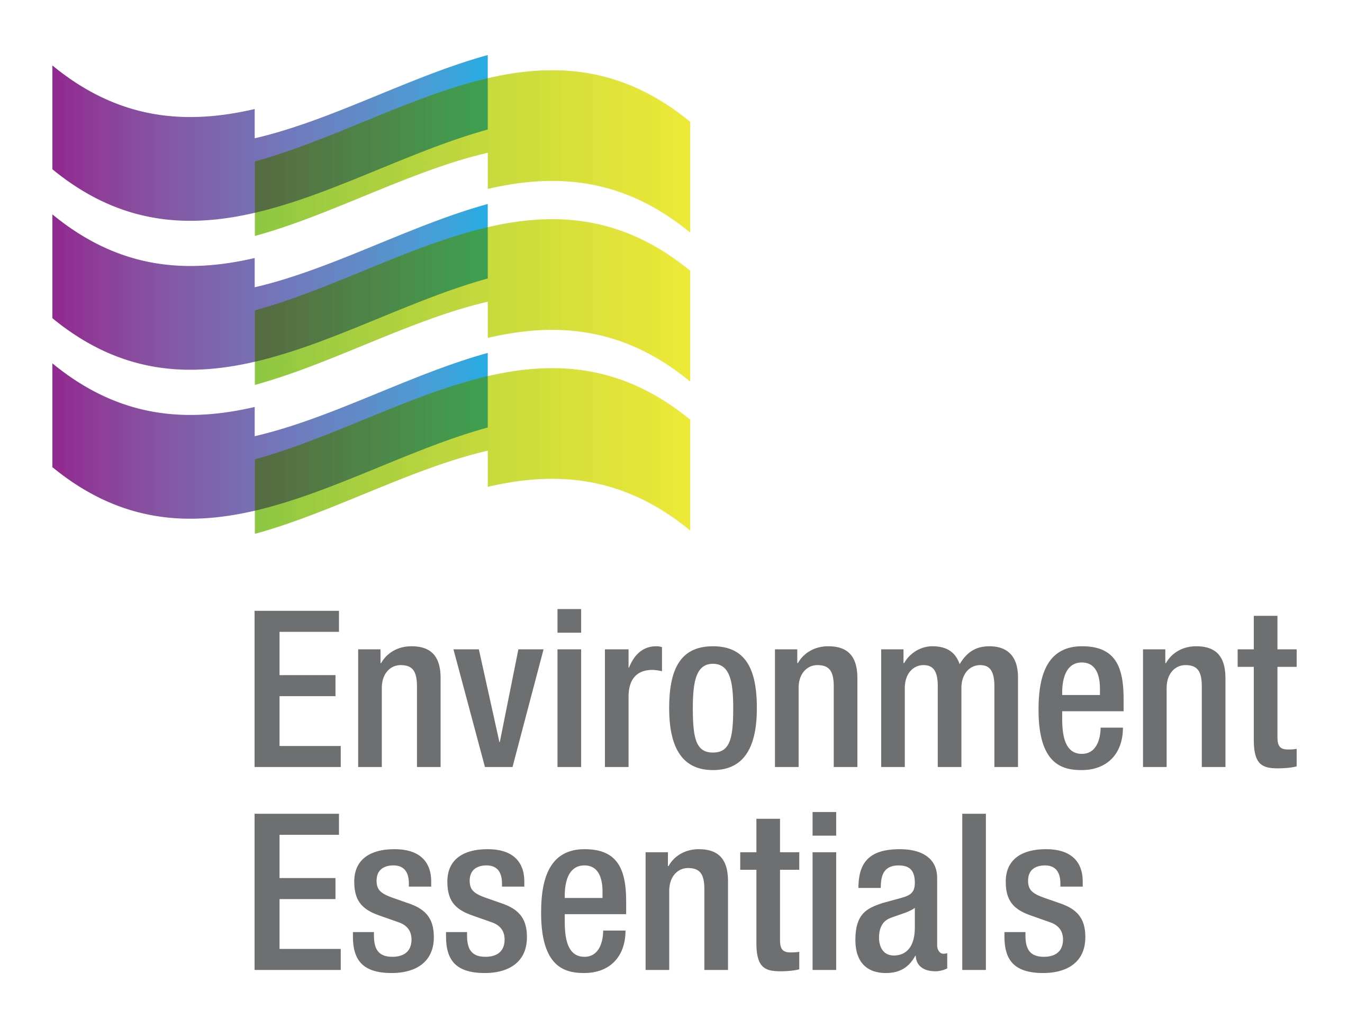 | COVID-19 (Novel Coronavirus)

Wednesday 31 March 2021
Please find below a selection of recent legislation changes relating to COVID-19 and communications for workplaces from key safety and environmental regulators in Australia and New Zealand.
This update is intended to be provided on a weekly basis.
Please note: The legislation in this update was current at time of release. Legislation around COVID-19 is being frequently updated and revoked. The URLs provided may no longer be maintained by the relevant legislation website, after the release date.

Legislation changes

Commonwealth

Coronavirus Economic Response Package (Payments and Benefits) Amendment Rules (No. 10) 2021 - allows financial institutions participating in the SME Recovery Loan Scheme to confirm that notices have been provided by the Commissioner of Taxation to entities concerning their election to participate in the JobKeeper program.
- Family Assistance Legislation Amendment (Early Childhood Education and Care Coronavirus Response and Other Measures) Act 2021 - amends the law relating to family assistance, and for related purposes.
- Guarantee of Lending to Small and Medium Enterprises (Coronavirus Economic Response Package) Amendment Rules 2021 - amends the definition of SME entity in the Rules to accommodate for the businesses that will be eligible to apply for loans under the SME Recovery Loan Scheme.
- Migration Amendment (Parent Visas) Regulations 2021 - provides for the grant of certain visas for applicants usually required to be outside Australia when the visa is granted who are in Australia during the COVID-19 pandemic under certain circumstances and for the grant of certain visas for applicants who are usually required to be in Australia when the visa is granted but are outside Australia during the COVID-19 pandemic under certain circumstances.

ACT
- Public Health (COVID-19 Affected Areas) Emergency Direction 2021 (No 5) - directs affected persons on commencement of COVID-19 areas of concern notice to undertake a period of quarantine and requires certain travellers to complete a self-declaration form.

NSW
- COVID-19 Concerns Notice and Exemption - identifies Brisbane City Council or Moreton Bay Regional Council an affected area for the purposes of clause 5 of the Public Health (COVID-19 Interstate Travellers) Order 2021.
- COVID-19 Legislation Amendment (Stronger Communities and Health) Act 2021 - amends a number of Acts and Instruments to extend emergency measures implemented as a result of the COVID-19 pandemic.
- COVID-19 Recovery Act 2021 - amends a number of Acts and Regulations to temporarily remake or extend measures implemented as a result of the COVID-19 pandemic and for other purposes.
- Public Health (COVID-19 Gathering Restrictions) Order 2021 - increases the maximum number of persons allowed to gather, removes requirements for COVID-19 Safety Hygiene Marshals, removes restrictions on indoor singing, dancing at weddings, restructures the Order and streamlines its provisions.
- Public Health (COVID-19 Mandatory Face Coverings) Order (No 2) 2021 - repeals and remakes the Public Health (COVID-19 Mandatory Face Coverings) Order 2021, and requires persons to wear fitted face coverings in certain circumstances inside NSW airports and on domestic commercial aircraft.
- Public Health (COVID-19 Restrictions on Gathering and Movement) Amendment Order (No 2) 2021 - amends the Public Health (COVID-19 Restrictions on Gathering and Movement) Order 2021 to clarify the maximum number of persons allowed on premises when the premises is being used as a nightclub and when the premises is being used for other purposes.
- Retirement Villages (COVID-19 Access to Retirement Villages) Order 2021 - exempts the operator of a retirement village from liability for non-compliance with Section 169 and 177 of the Retirement Villages Act 1999 and Clause 11(2)(d) and (e) of Schedule 3A of the Retirement Villages Regulation 2017.
- Retirement Villages (COVID-19 Budget and Expenditures) Order 2021 - exempts the operator of a retirement village and residents of a retirement village from liability for non-compliance with certain sections of the Retirement Villages Act 1999 under certain circumstances.
- Retirement Villages (COVID-19 Consent of Residents) Order 2021 - exempts the residents of a retirement village from the operation of Section 9 and Schedule 1 of the Retirement Villages Act 1999.
- Retirement Villages (COVID-19 Meeting Requirements) Order 2021 - exempts the operator of a retirement village from liability for non-compliance with Section 41, 69A and 72 of the Retirement Villages Act 1999 in certain circumstances.
- Retirement Villages (COVID-19 Services & Facilities) Order 2021 - exempts the operator of a retirement village from liability for non-compliance with Section 60, 61 and 62 of the Retirement Villages Act 1999 in certain circumstances.
- Retirement Villages (COVID-19 Village Rules) Order 2021 - exempts the operator of a retirement village from liability for non-compliance with Section 51 of the Retirement Villages Act 1999 under certain circumstances.

NT
- COVID-19 Directions (No. 4) 2021: Cruise Vessels - prohibits certain cruise vessels from entering territory waters and from operating in territory waters without an approved COVID-19 management plan, among other things.

QLD
- Public Health (Further Extension of Declared Public Health Emergency - COVID-19) Regulation 2021 - extends the period of the declared public health emergency to ensure the Queensland Government can continue to respond to any outbreak of COVID-19 in Queensland and to allow for emergency powers to be used to reduce the risk of COVID-19 spreading in Queensland.
- Queensland COVID-19 Restricted Areas (No. 13) - identifies the City of Brisbane and Moreton Bay Region as Queensland COVID-19 restricted areas for the Public Health Direction - Aged Care (No. 25) or its successors, the Public Health Direction - Disability Accommodation Services (No. 16) or its successors, and the Public Health Direction - Hospital Visitors (No. 18) or its successors.
- Restrictions for Impacted Areas Direction No. 3 - requires persons in impacted areas to confine at home except for certain reasons, restricts gatherings, requires physical distancing, restricts the operation of certain non-essential businesses, activities and undertaking in impacted areas, restricts entry to impacts areas, and requires persons in, or who have been in, impacted areas to wear a face mask.
- School and Early Childhood Service Exclusion Direction - requires educators and staff members who suspect a child in their care is unwell with contagious illness to notify the parent or guardian and the parent or guardian must collect the child as soon as possible.

TAS

Direction Under Section 16 - (Contact Tracing - No. 4) - requires owners and occupiers of certain premises to keep specified information, and refuse entry to a person who fails to provide that information.
- Direction Under Section 16 - (Testing of Workers at Quarantine Sites - No. 1) - prescribes testing requirements for workers at quarantine sites.

VIC

- Care Facilities Directions (No 25) - repeals the Care Facilities Directions (No 24) and makes provisions for restricted access to care facilities in order to limit the spread of COVID-19 within a particularly vulnerable population, balancing the need to limit the spread of COVID-19 against the broader responsibilities of care facilities to the physical, emotional and psychological wellbeing of their clients - came into force at 6:00 pm on 26 March 2021.
- COVID-19 Omnibus (Emergency Measures) Transitional Regulations 2021 - provides for transitional matters arising as a result of the repeal of Part 16 of the Residential Tenancies Act 1997.
- Diagnosed Persons and Close Contacts Directions (No 20) - repeals the Diagnosed Persons and Close Contacts Directions (No 19) and requires persons diagnosed with COVID-19 to self-isolate, and who are living with a diagnosed person, or who have been in close contact with a diagnosed person, to self-quarantine to limit the spread of COVID-19 - came into force at 6:00 pm on 27 March 2021.

Education and Training Reform Amendment (COVID-19 Emergency Measures Extension) Regulations 2021 - amends the Education and Training Reform Regulations 2017 to extend the date prescribed for the revocation of Part 13 of those Regulations.

Justice Legislation Amendment (System Enhancements and Other Matters) Act 2021 - amends various Acts to provide for the on-going operation of certain processes and procedures implemented during the COVID-19 pandemic and extends the operation of certain provisions relating to the COVID-19 pandemic in various Acts.
- Public Health Emergency Order Under Section 22G - authorises certain pharmacists to sell or supply a schedule 4 poison without a prescription to a person in an emergency in certain circumstances.
- Public Health Emergency Order Under Section 22G - facilitates possession, use, sale or supply of a schedule 4 poison (other than a drug of dependence) by certain practitioners, enables pharmacists to sell or supply certain schedule 4 poisons on an electronically transmitted digital image of an original prescription directly to the pharmacist from a practitioner, and clarifies requirements for repeat supply by a pharmacists in regards to electronically transmitted images of prescriptions.
- Restricted Activity Directions (Victoria) (No 11) - repeals the Restricted Activity Directions (Victoria) (No 10) and restrict the operation of certain businesses and undertakings in the State of Victoria to address the serious public health risk posed to Victoria by COVID-19 - came into force at 6:00 pm 26 March 2021.
- Stay Safe Directions (Victoria) (No 18) - repeals the Stay Safe Directions (Victoria) (No 17) and requires anyone who ordinarily resides in Victoria to limit interactions with others by restricting gatherings, and to carry and wear face coverings in certain settings - came into force at 6:00 pm on 26 March 2021.
- Victorian Border Crossing Permit Directions (No 8) - repeals the Victoria Border Crossing Permit Directions (No 7) and continues to provide a ‘traffic light’ border crossing scheme for persons seeking to enter Victoria from any other State or Territory in Australia or, after entering Australia, from a Green Zone Country, in order to limit the spread of COVID-19 - came into force at 6:00 pm on 26 March 2021.
- Workplace Directions (No 23) - repeals the Workplace Directions (No 22) to limit the number of Victorians attending Work Premises to assist in reducing the frequency and scale of outbreaks of COVID-19 in Victorian workplaces, and to establish more specific obligations on employers and workers in relation to managing the risk associated with COVID-19 - came into force at 6:00 pm on 26 March 2021.
- Workplace (Additional Industry Obligations) Directions (No 20) - repeals the Workplace (Additional Industry Obligations) Directions (No 19) to establish additional specific obligations on employers and workers in specific industries in relation to managing the risk associated with COVID-19 - came into force at 6:00 pm on 26 March 2021.

WA

Commercial Tenancies (COVID-19 Response) Amendment Regulations (No. 2) 2021 - amends the Commercial Tenancies (COVID-19 Response) Act 2020.
- Extension of Declaration (No. 2) of Public Health State of Emergency - extends the public health state of emergency declaration, which came into effect on 23 March 2020 for 14 days.
- Extension of State of Emergency Declaration - extends the state of emergency declaration made on 15 March 2020 until 9 April 2021.

NZ
- COVID-19 Response (Requirements for Entities - Modifications and Exemptions) (Māori Trust Boards - Annual Hui) Notice 2021 - grants an exemption from section 23C(1) of the Maori Trust Boards Act 1955 to postpone, or has postponed, the hui because of the effects of COVID-19.
- COVID-19 Response (Requirements for Entities - Modifications and Exemptions) (Māori Trust Boards -Electronic Voting in Elections) Notice 2021 - grants an exemption to enable votes for membership of a Māori Trust Board to be cast electronically as opposed to the postal ballot.

From the regulators

Australia
- Department of Health: Top 3 COVID-19 Vaccine Questions - Vaccine Rollout Phase 1B, Vaccine Appointments and What to Bring
- Therapeutic Goods Administration: Post-Approval Changes to COVID-19 Vaccines

ACT

ACT Government:

New COVID-19 Exposure Sites in Greater Brisbane

New Travel Restrictions for People Travelling from Greater Brisbane
  - Strengthened Travel Advice for Greater Brisbane
  - Update for Travel Advice for Greater Brisbane

NSW
- NSW Government:

COVID-19 Restrictions to Ease but Compliance Must Increase

NSW Health:
  - Public Health Alert - Arrivals from Brisbane
  - Public Health Alert - NSW Response to Brisbane Cases
  - Public Health Alert - Stay at Home Restrictions
  - Public Health Alert - Updated Venue Advice

NT

NT Government:
  - COVID-19 Australian Hotspots and Travel Restrictions
  - COVID-19 Update: Additional Testing Requirements for Brisbane
  - COVID-19 Update: Testing Requirements for Brisbane

QLD

Queensland Government:
  - Greater Brisbane 3-Day Lockdown
  - Public Health Alert: Brisbane and Moreton Bay Regions
  - Restrictions for Queensland (Outside of Greater Brisbane)

TAS
- Tasmanian Government:
  - Changes to Tenant and Landlord Support Measures
  - COVID-19 Wastewater Testing Program to Commence
  - Extending Financial Support for Tasmanian Tenants and Landlords
  - Queensland High-Risk Premises
  - Queensland Travel Restrictions
  - Vaccination Rollout Program Update
  - Vaccine Update and Wastewater Testing in Tasmania

WA

WA Government:
  - Updated Public Health Alert for Arrivals from Queensland
  - WA Introduces Hard Border with Queensland

NZ

NZ Government:
  - COVID-19 Vaccine for Urgent Overseas Travel
  - One Year On: Alert Level 4 Lockdown
- NZTA: Easter Traffic Hotspots and Advice for a Safe Journey This Weekend

That completes this edition of the COVID-19 update. The next update will be released on Wednesday 7 April 2021.

Environment Essentials Pty Ltd ǀ ABN: 29 103 207 638
A Suite 8 / 8 Clay Drive, Doncaster Vic 3108, Australia ǀ T +61 3 9095 6533
W www.enviroessentials.com.au

