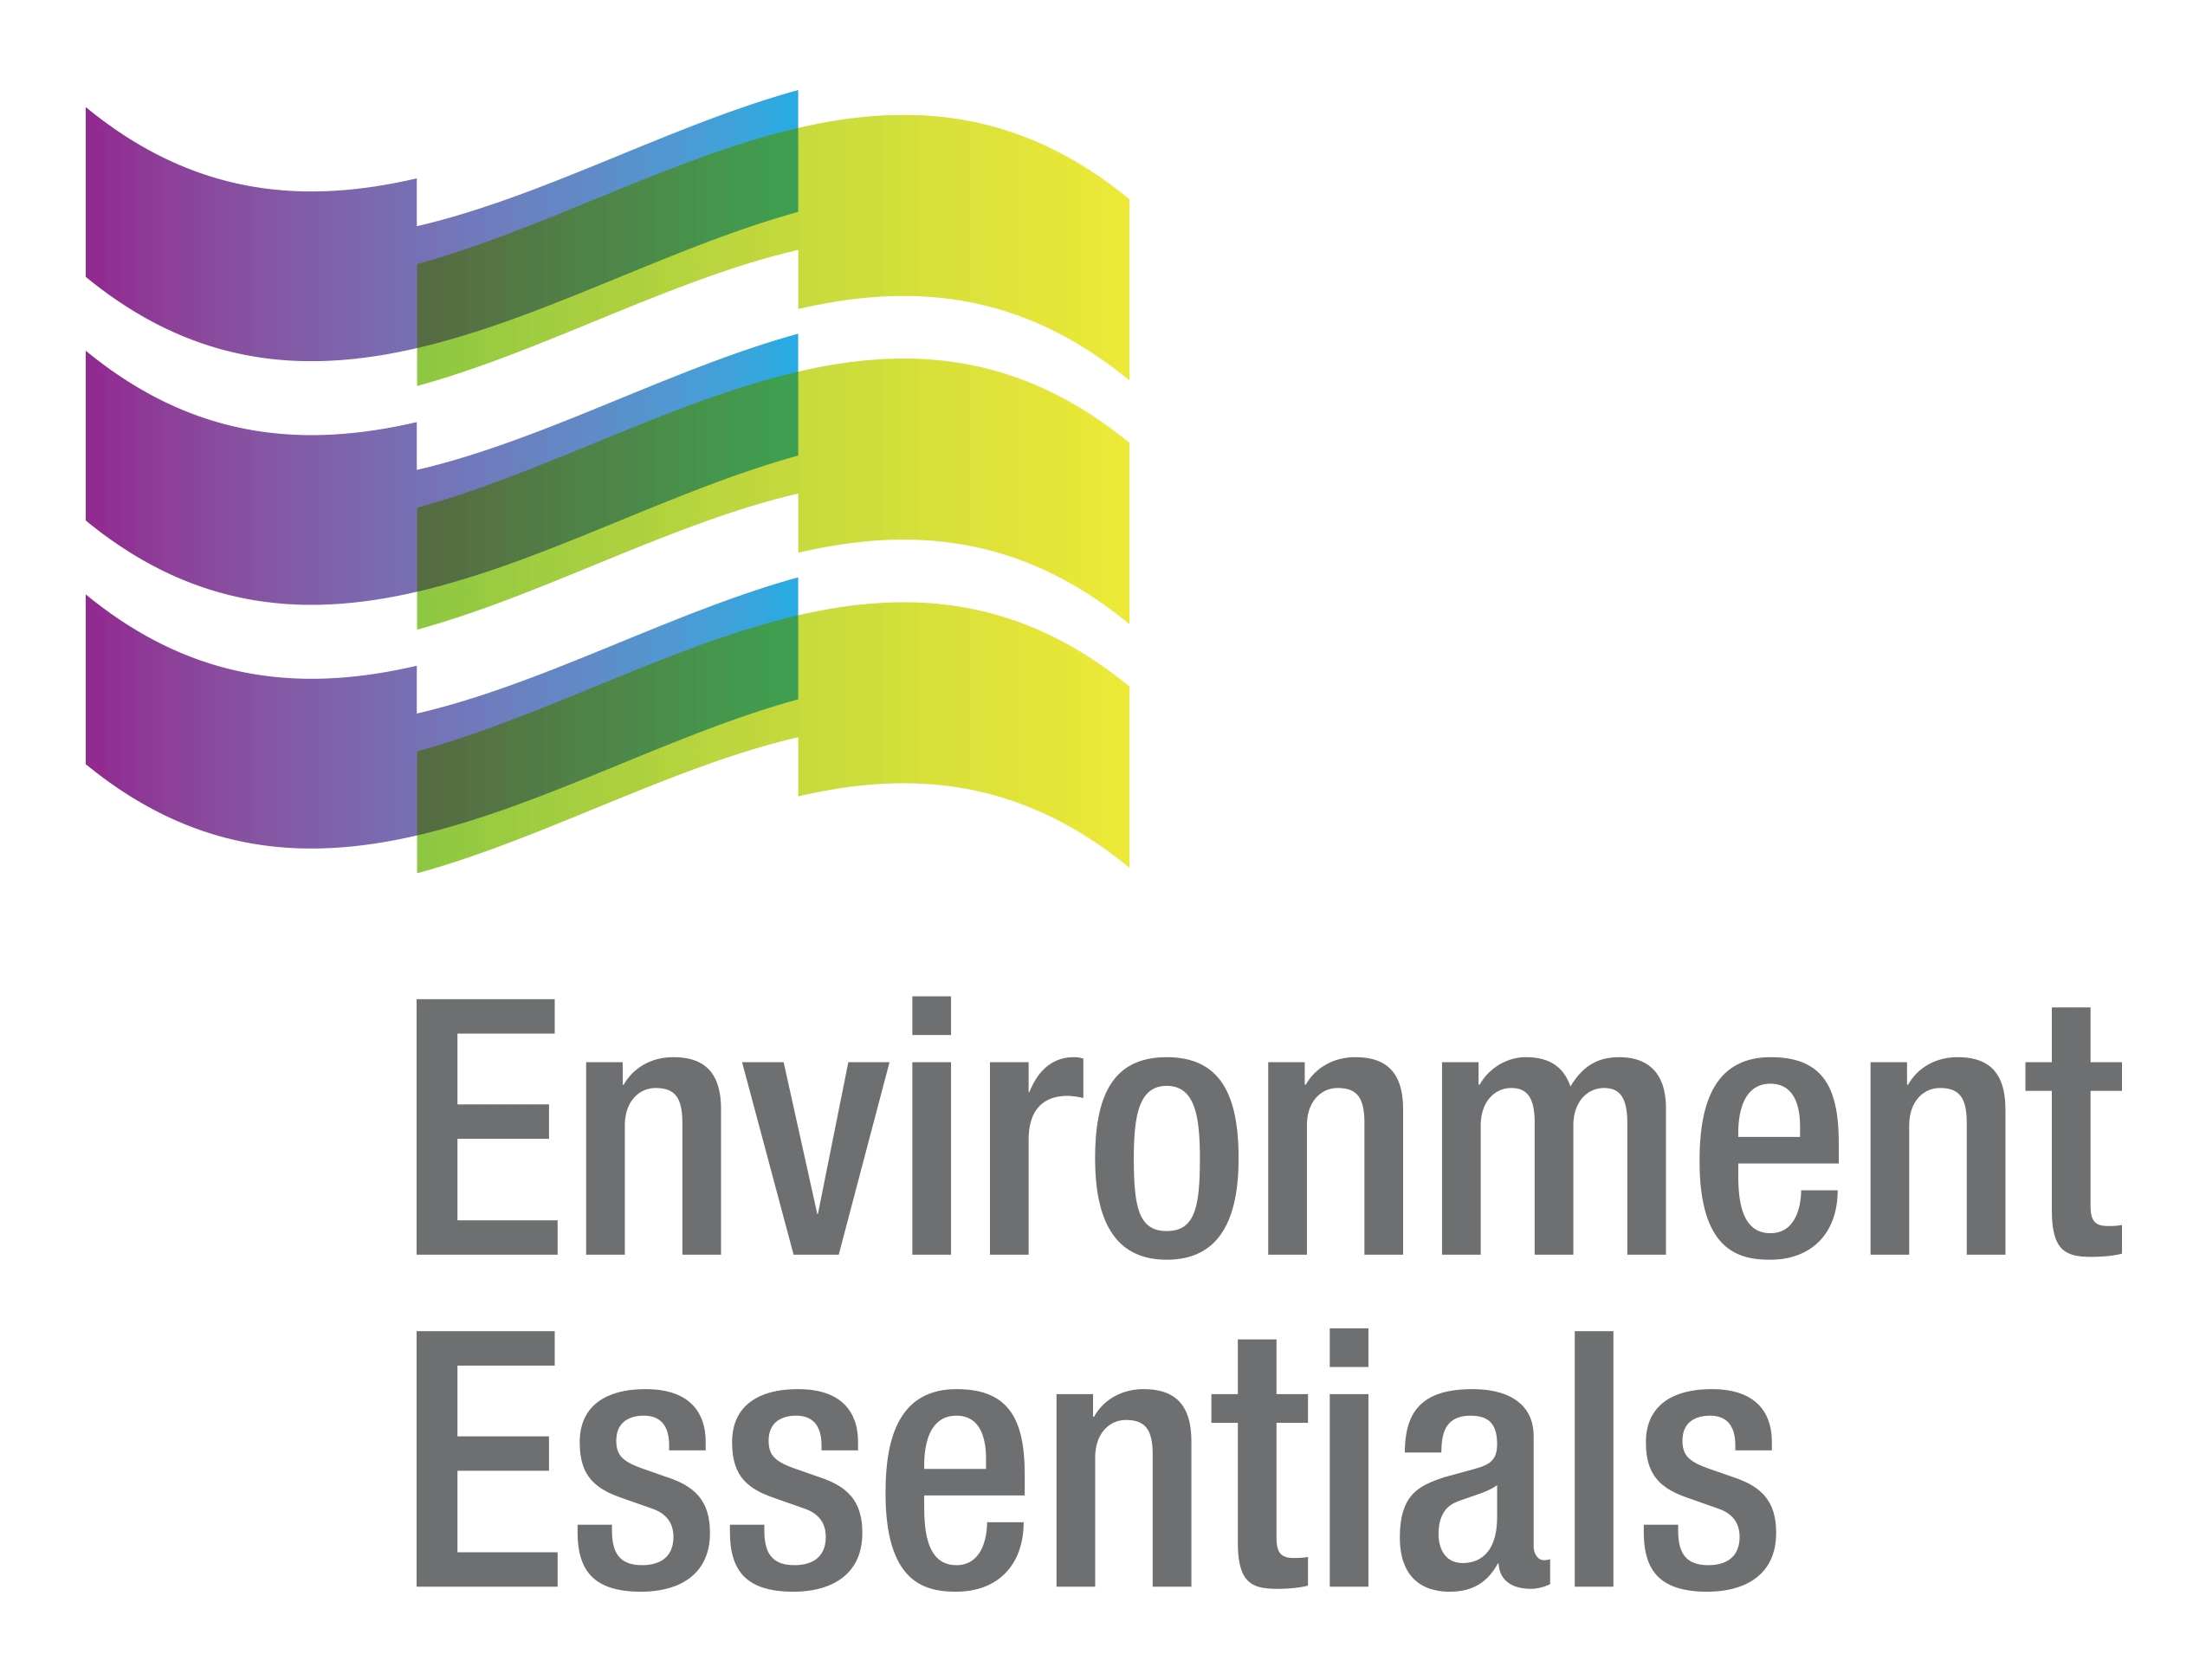 | COVID-19 (Novel Coronavirus)

Wednesday 3 March 2021
Please find below a selection of recent legislation changes relating to COVID-19 and communications for workplaces from key safety and environmental regulators in Australia and New Zealand.
This update is intended to be provided on a weekly basis.
Please note: The legislation in this update was current at time of release. Legislation around COVID-19 is being frequently updated and revoked. The URLs provided may no longer be maintained by the relevant legislation website, after the release date.

Legislation changes

Commonwealth
- Aged Care (Subsidy, Fees and Payments) Amendment (Cessation of Temporary Home Care Viability Supplement Funding Increases) Determination 2021 - ceases, from 1 March 2021, temporary home care viability supplement funding increases payable to approved aged care providers.
- Migration Amendment (2021 Measures No. 1) Regulations 2021 - makes various amendments to the Migration Regulations 1994, including to assist certain visa applicants and holders adversely affected by COVID-19 and to support the attraction of Global Talent to Australia.
- Migration (Class of Persons for Temporary Skill Shortage (Class GK) Visa Nil VAC) Instrument (LIN 21/006) 2021 - specifies that certain former visa holders and current visa holders can apply for a new visa with a nil visa application charge if they meet certain circumstances specified in the instrument.
- Migration (Class of Persons for Visitor (Class FA) Visa Nil VAC) Instrument (LIN 21/021) 2021 - specifies that certain former Subclass 600 (Visitor) visa holders can apply for a new Subclass 600 visa with a nil visa application charge (VAC) where their travel to or stay in Australia (or both) has been affected by the COVID-19 pandemic.
- Migration (Post COVID-19 Economic Recovery Event for Subclass 408 Visas) Instrument (LIN 21/008) 2021 - provides that the period of recovery from the economic effects of COVID-19 in Australia is a specified event under paragraph 408.229(b) of Schedule 2 to the Migration Regulations 1994.
- Migration (Refund of Visa Application Charge) Instrument (LIN 21/007) 2021 - specifies circumstances where certain visa holders and former visa holders who have been impacted due to COVID-19 travel restrictions introduced on 20 March 2020 are allowed refunds of the first instalment of a visa application charge.
- Therapeutic Goods Amendment (2020 Measures No. 2) Act 2021 - makes amendments to the Therapeutic Goods Act 1989, including removing a potential impediment to the timely availability of COVID-19 vaccines in Australia by enabling the Secretary to consent to the importation and supply of registered or listed therapeutic goods that do not have their registration or listing number on the label.

ACT
- Public Health (Public Health Risk Activity Licensing Exemption) Determination 2021 (No 1) - exempts pathology collection centres from requiring a public health risk activity licence under the Public Health (Risk Activities) Declaration 2005 (No 1) because they are already adequately regulated by the Commonwealth Government.
- Public Health (Restricted Activities - Gatherings, Business or Undertakings) Emergency Direction 2021 (No 2) - restricts non-essential gatherings and the operation of non-essential businesses and undertakings in order to limit the spread of COVID-19.

NSW
- Public Health (COVID-19 Restrictions on Gathering and Movement) Order 2021 - amends the Public Health (COVID-19 Restrictions on Gathering and Movement) Order (No. 7) 2020 to increase the number of people allowed to gather at specified premises and to increase the number of people allowed to participate in certain activities, such as dancing at a wedding.
- Public Health (COVID-19 Sydney Gay and Lesbian Mardi Gras Arrangements) Order 2021 - imposes certain restrictions concerning gatherings for the purposes of, and related to, the Sydney Gay and Lesbian Mardi Gras 2021.

NT
- Medicines, Poisons and Therapeutic Goods Amendment Act 2021 - allows the CHO to approve protocols for possessing, supplying or administering COVID-19 vaccine and to authorise a person or class of persons to possess, supply or administer a COVID-19 vaccination in accordance with the protocol.

QLD
- Electoral (Provision of Information on Electoral Rolls) Amendment Regulation 2021 - prescribes Queensland Health as the department in which the Public Health Act 2005 is administered, as an entity that the Electoral Commission of Queensland may give a copy of the most recent version of the entire, or part of the electoral roll for any electoral district, and prescribes the circumstances in which certain information may be given to Queensland Health for the purpose of contacting persons in Queensland in relation to the Australian COVID-19 vaccination arrangements.

SA
- Emergency Management (Cross Border Travel No 40) (COVID-19) Direction 2021 - continues to impose restrictions and requirements on people who are entering South Australia from overseas (including New Zealand).

Emergency Management (Public Activities No 20) (COVID-19) Direction 2021 - imposes principles and rules relating to the conduct of certain activities involving members of the public, and the management of places in which the activities occur, for the purpose of minimising the spread of COVID-19.
- Emergency Management (Quarantine and Testing of Certain Former Victorian Arrivals No 5) (COVID-19) Direction 2021 - requires all restricted former Victorian arrivals to submit to a COVID-19 test and for certain arrivals to quarantine.
- Emergency Management (Residential Aged Care Facilities No 32) (COVID-19) Direction 2021 - prohibits the entry of persons into residential aged care facilities except in certain circumstances, limits the provision of personal care by personal care workers to one facility, and requires such facilities to adopt a Workforce Management Plan and COVID-19 Infection Control Plan, among other things.
- Emergency Management (Supervised Quarantine No 5) (COVID-19) Direction 2021 - specifies testing and other requirements for employees and contractors at medi-hotels, and requirements for persons undertaking supervised quarantine.

TAS

Direction Under Section 16 (Quarantine - No. 4) - directs identified contacts to quarantine and undergo a COVID-19 test.
- Direction Under Section 16 (Residential Aged Care Facilities - No. 11) - prohibits the entry of persons into residential aged care facilities except in certain circumstances.

VIC

Care Facilities Directions (No. 23) - prohibits non-essential visits and access to care facilities to limit the spread of COVID-19 within a particularly vulnerable population - came into force at 11.59 pm on 26 February 2021.
- COVID-19 Omnibus (Emergency Measures) (Commercial Leases and Licences) Amendment Regulations 2021 - amends the definition of SME entity under the COVID-19 Omnibus (Emergency Measures) (Commercial Leases and Licences) Regulations 2020.
- Diagnosed Persons and Close Contacts Directions (No 17) - requires persons diagnosed with COVID-19 to self-isolate, and persons living or in close contact with a diagnosed person to self-quarantine - came into force at 11:59 pm on 26 February 2021.
- Extension of Declaration of a State of Emergency - extends the declaration of a state of emergency made on 16 March 2020 until 11:59 pm on 15 March 2021.
- Hospital Visitor Directions (No 21) - prohibits certain visits to hospitals in order to limit the spread of COVID-19 - came into force at 11:59 pm on 26 February 2021.
- Restricted Activity Directions (Victoria) (No 9) - restricts the operation of certain businesses and undertakings in the State of Victoria to address the serious public health risk posed to Victoria by COVID-19 - came into force at 11.59 pm 26 February 2021.
- Stay Safe Directions (Victoria) (No 16) - requires face coverings to be carried and worn in certain circumstances and removes restrictions on the circumstances in which people can leave the premises of where they ordinarily reside - came into force at 11.59 pm on 26 February 2021.
- Victorian Border Crossing Permit Directions (No 6) - continues to provide a ‘traffic light’ border crossing scheme for persons seeking to enter Victoria from other States and the Territories, or after entering Australia from a Green Zone Country, in order to limit the spread of COVID-19 - came into force at 11:59 pm on 26 February 2021.
- Workplace (Additional Industry Obligations) Directions (No 18) - establishes additional specific obligations on employers and workers in specific industries in relation to managing the risk associated with COVID-19 - came into force at 11.59 pm on 26 February 2021.
- Workplace Directions (No 21) - limits the number of Victorians attending work premises to assist in reducing the frequency and scale of COVID-19 outbreaks and to establish more specific obligations on employers and workers in relation to managing the risk associated with COVID-19 - came into force at 11.59 pm on 26 February 2021.

NZ
- COVID-19 Public Health Response (Alert Level Requirements) Order (No 4) 2021 - moves Auckland from alert level 2 to alert level 3.
- Exemption of Persons and Services from Requirements of the COVID-19 Public Health Response (Alert Level Requirements) Order (No 4) 2021 - exempts funeral directors and embalmers from Clause 19 of the COVID-19 Public Health Response (Alert Level Requirements) Order (No 4) 2021.

From the regulators

Australia
- Federal Register of Legislation: Invitation to Comment on the Assessment of the Janssen-Cilag COVID-19 Vaccine
- Therapeutic Goods Administration: TGA Collecting COVID-19 Vaccine Side Effect Reports
- Safety, Rehabilitation and Compensation Commission: COVID-19 Vaccination and the Workplace

ACT

ACT Government:
  - Check in CBR App to be Made Mandatory
  - Update to New Zealand Travel Advice
  - Update to Victoria Travel Restrictions

NSW

NSW Government:

NSW Prepares for Vaccine Rollout Across the State
  - Restrictions Will be Eased from 26 February

NT

NT Government: Auckland, NZ Declared a Hotspot

QLD

QLD Government: New Check in Qld App Makes COVID-Safe Simpler in Queensland
- WorkSafe QLD: COVID-19 Vaccines and Your Workplace Health and Safety Obligations

SA
- SA Government:
  - COVID-19 Vaccine Provisions for Public Sector Workforce
  - SES’s COVID-19 Support a Shot in the Arm for SAPOL
  - Third COVID-19 Vaccine Freezer Arrives
  - Victorian Restrictions to Ease Friday

TAS
- Tasmanian Government:
  - Auckland Declared a High-Risk Region
  - COVID-19 Update: New Zealand
  - Restrictions on Visits to Residential Age Care Facilities Lifted
  - Vaccine Rollout in Full Swing

VIC

Victorian Government:
  - Protecting Victorians and Staying COVIDSafe
  - Vaccine Rollout Continues to Ramp Up Across Victoria
  - Victoria to Return to COVIDSafe Settings

WA

Department of Health: WA Marks First Week of Vaccination
- Department of Mines, Industry Regulation and Safety:
  - COVID-19 Ending a Fixed-term Tenancy Agreement
  - COVID-19 Residential Tenancies Emergency Period Extension - Landlord Fact Sheet
  - Rent Increases During COVID-19

NZ

Ministry of Business, Innovation and Employment: Business Travel Register Open

NZ Government:

Advice for Those Travelling In, Out and Through Auckland to Return Home

Alert Level 2

Alert Level 3

Support in Place for People Connected to Auckland COVID-19 Cases

That completes this edition of the COVID-19 update. The next update will be released on Wednesday 10 March 2021.

Environment Essentials Pty Ltd ǀ ABN: 29 103 207 638
A Suite 8 / 8 Clay Drive, Doncaster Vic 3108, Australia ǀ T +61 3 9095 6533
W www.enviroessentials.com.au

