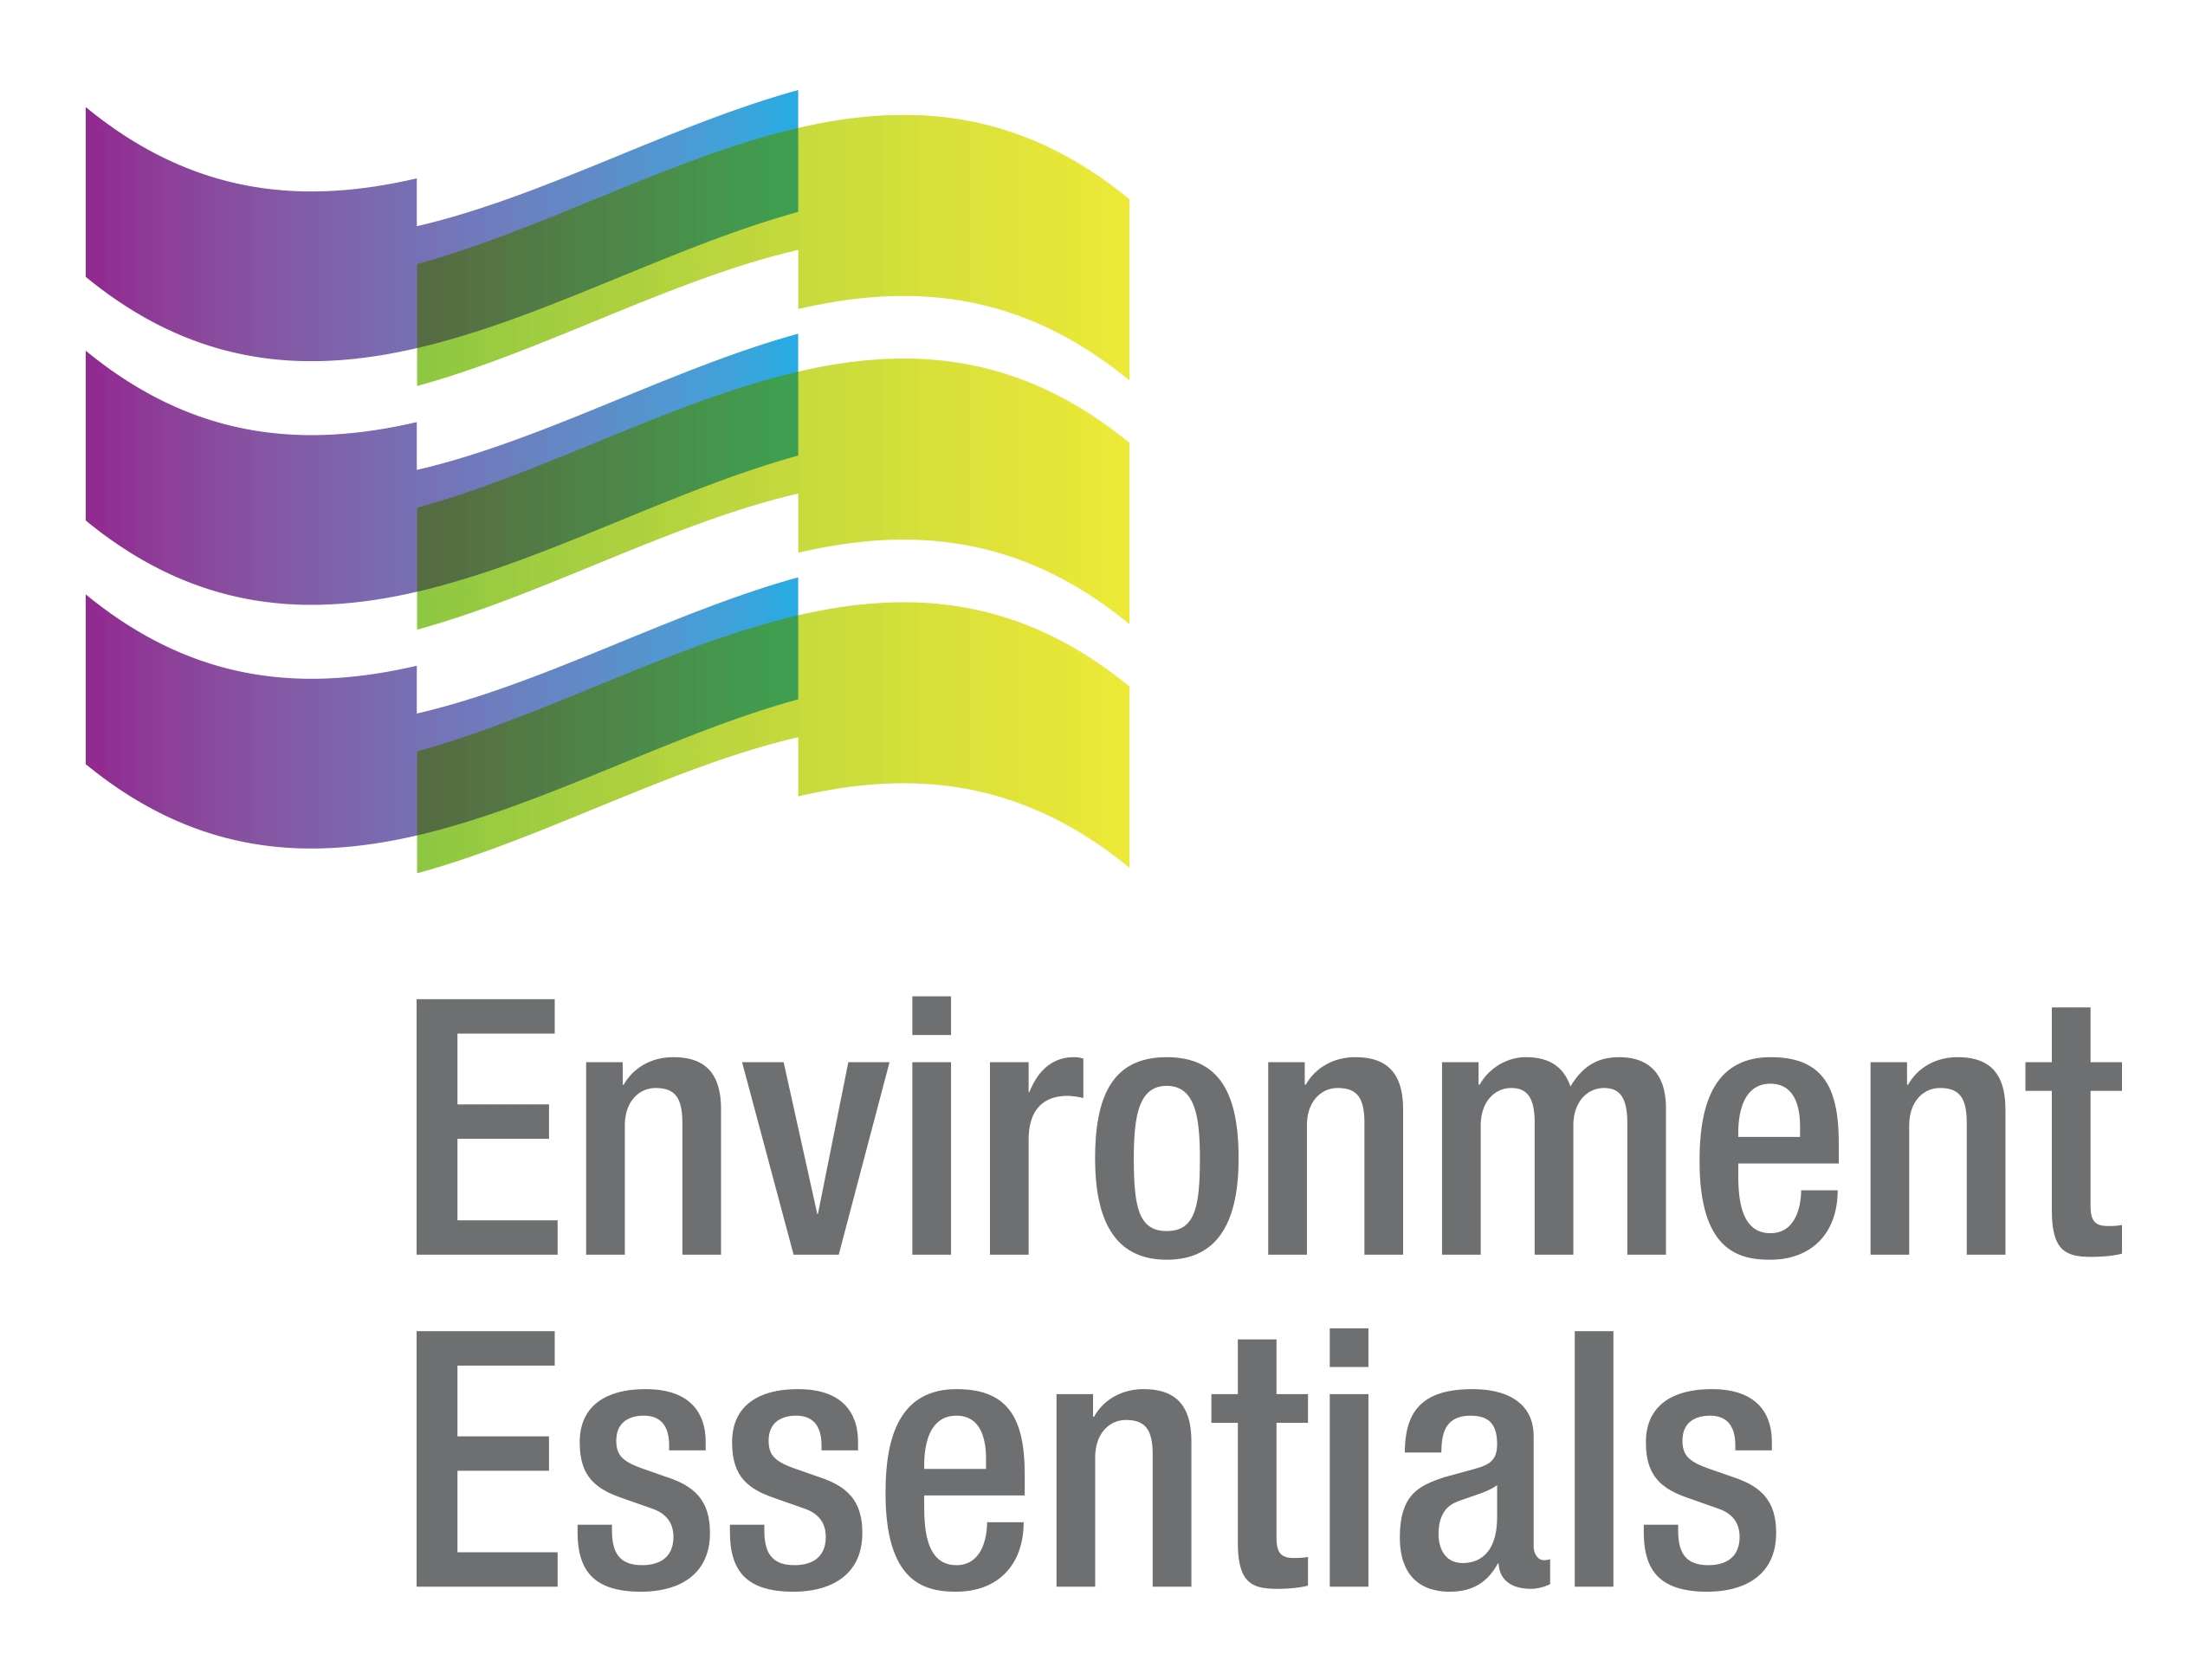 | COVID-19 (Novel Coronavirus)

Wednesday 27 January 2021
Please find below a selection of recent legislation changes relating to COVID-19 and communications for workplaces from key safety and environmental regulators in Australia and New Zealand.
This update is intended to be provided on a weekly basis.
Please note: The legislation in this update was current at time of release. Legislation around COVID-19 is being frequently updated and revoked. The URLs provided may no longer be maintained by the relevant legislation website, after the release date.

Legislation changes

Commonwealth
- Biosecurity (Human Biosecurity Emergency) (Human Coronavirus with Pandemic Potential) (Emergency Requirements - Incoming International Flights) Determination 2021 - implements additional public health measures regarding face masks, COVID-19 testing and close contacts, and applies to international flights commencing outside Australia from 22 January 2021.
- Biosecurity (Human Coronavirus with Pandemic Potential) (Preventative Biosecurity Measures - Incoming International Flights) Determination 2021 - implements additional public health measures regarding face masks, COVID-19 tests and close contacts, and applies to international flights commencing outside Australia from 22 January 2021.
- Child Care Subsidy Amendment (Coronavirus Response Measures No. 1) Minister’s Rules 2021 - amends the Child Care Subsidy Minister’s Rules 2017 to ensure that payments made by Victoria to kindergarten providers do not reduce the hourly rate of Child Care Subsidy that individuals are entitled to.

ACT
- Public Health (COVID-19 Interstate Hotspots) Emergency Direction 2021 (No. 8) - replaces the Public Health (COVID-19 Interstate Hotspots) Emergency Direction 2021 (No. 7) and gives directions regarding travel from interstate hotspots into the ACT to alleviate the emergency as declared in the Public Health (Emergency) Declaration 2020.
- Public Health (Mandatory Face Masks - Canberra Airport and Domestic Flights) Emergency Direction 2021 - requires persons to wear a face mask at Canberra airport, and while on a domestic commercial aircraft into and out of Canberra airport, at all times unless an exemption applies.
- Taxation Administration (Payroll Tax - Businesses Not Permitted to Operate) COVID-19 Exemption Scheme Determination 2021 - follows on from the operation of the Taxation Administration (Payroll Tax - Businesses Not Permitted to Operate) COVID-19 Exemption Scheme Determination 2020 to provide payroll tax exemption to eligible employers until 30 June 2021.
- Taxation Administration (Payroll Tax) COVID-19 Exemption Scheme Determination 2021 - extends the operation of the Taxation Administration (Payroll Tax) COVID-19 Exemption Scheme Determination 2020 until 30 June 2021.

SA

COVID-19 Emergency Response Modification of Public Finance and Audit Act 1987 Expiry Notice 2021 - notifies the expiry of Clause 4 of Part 4 of Schedule 2 to the COVID-19 Emergency Response Act 2020.
- COVID-19 Emergency Response Provisions Applying to Commercial Leases - Regulations Expiry Notice 2021 - notifies the expiry of Section 7 of Part 2 of the COVID-19 Emergency Response Act 2020.

Emergency Management (Cross Border Travel No 30) (COVID-19) Direction 2021 - replaces the Emergency Management (Cross Border Travel No 29) Direction 2021, prohibits certain persons from entering South Australia, and directs certain persons to quarantine, submit to COVID-19 testing and wear face masks.

Emergency Management (Public Activities No 18) (COVID-19) Direction 2021 - imposes principles and rules relating to certain activities involving members of the public, and management of places in which these activities occur, to minimise the spread of COVID-19.

Emergency Management (Residential Aged Care Facilities No 23) (COVID-19) Direction 2021 - prohibits the entry of persons into residential aged care facilities except in certain circumstances, and requires such facilities to adopt a Workforce Management Plan and COVID-19 Infection Control Plan, among other things.

TAS

Direction Under Section 16 - Arrival Requirements for Certain Travellers into Tasmania No. 4 - requires certain travellers arriving in Tasmania to undergo clinical assessments and testing to manage the threat of COVID-19.
- Direction Under Section 16 - Isolation No. 4 - requires persons diagnosed with COVID-19 to isolate according to the Direction.
- Direction Under Section 16 - Quarantine No. 2 - requires certain identified contacts and close contacts to be tested and to quarantine according to the Direction.

VIC

- Stay Safe Directions (Victoria) (No 11) - replaces the Stay Safe Directions (Victoria) (No 10), clarifies the requirement to wear coverings when visiting hospitals and increases the daily private social gathering limit from 15 to 30 persons - came into force at 11.59 pm on 22 January 2021.
- Victorian Border Crossing Permit Directions (No. 4) - replaces the Victorian Border Crossing Directions No. 3 and makes minor changes to current border crossing restrictions - came into force at 11:59 pm on 22 January 2021.

WA

Public Health (Notifiable Infectious Disease) Order (No. 3) 2020 - declares COVID-19 to be a notifiable infectious disease and an urgently notifiable infectious disease under Section 90(2) of the Public Health Act 2016.

NZ
- COVID-19 Public Health Response (Air Border) Order (No 2) 2020 - Designation of Specified Places - replaces the Designation of Specified Places - COVID-19 Public Health Response (Air Border) Order (No 2) 2020 and designates a list of countries or regions as specified places under Clause 4 of the COVID-19 Public Health Response (Air Border) Order (No 2) 2020.
- Exemption of Persons from Clause 8(2B) of the COVID-19 Public Health Response (Air Border) Order (No 2) 2020 - exempts certain classes of persons returning to New Zealand, who have met specified criteria, from Clause 8(2B) of the COVID-19 Public Health Response (Air Border) Order (No 2) 2020.

From the regulators

Australia

Comcare: Transitioning to the Usual Workplace as COVID-19 Restrictions Ease
- Department of Health: Mobilising Australia’s COVID-19 Vaccine Workforce
- Therapeutic Goods Administration:
  - COVID-19 Vaccine: Provisional Registrations
  - ICMRA Statement for Healthcare Professionals: How COVID-19 Vaccines Will Be Regulated for Safety and Effectiveness
  - TGA Grants Additional Provisional Determination for a COVID-19 Vaccine
  - TGA Provisionally Approves Pfizer COVID-19 Vaccine

ACT

ACT Government:

Commercial Tenancies Relief Supports Hundreds of Businesses Impacted by COVID-19
  - More Support for Canberra’s Tourism Industry

QLD

Business Queensland: Greater Brisbane Restrictions Eased

The Queensland Cabinet and Ministerial Directory: Greater Brisbane Restrictions Set to Ease

TAS
- King Island Council: No Government Quarantine Facilities on King Island

VIC

Victorian Government: More Victorians in the Home and Fewer Red Zones

WA

Western Australian Government:

COVID-19 Coronavirus: Controlled Interstate Border - Updated 22 January 2021

NSW and Queensland Move to ‘Low Risk’

NZ

Ministry of Health: Update on UK and SA Variants in Managed Isolation

New Zealand Government:

COVID-19 Vaccine Slated for Possible Approval Next Week

Pre-departure Testing Extended to All Passengers to New Zealand

Voluntary Saliva Testing Offered to Quarantine Workers from Monday

Other
- World Health Organisation: Statement to the 148th Executive Board by the Chair of the Review Committee on the Functioning of the International Health Regulations (2005) during the COVID-19 Response

That completes this edition of the COVID-19 update. The next update will be released on Wednesday 3 February 2021.

Environment Essentials Pty Ltd ǀ ABN: 29 103 207 638
A Suite 8 / 8 Clay Drive, Doncaster Vic 3108, Australia ǀ T +61 3 9095 6533
W www.enviroessentials.com.au

