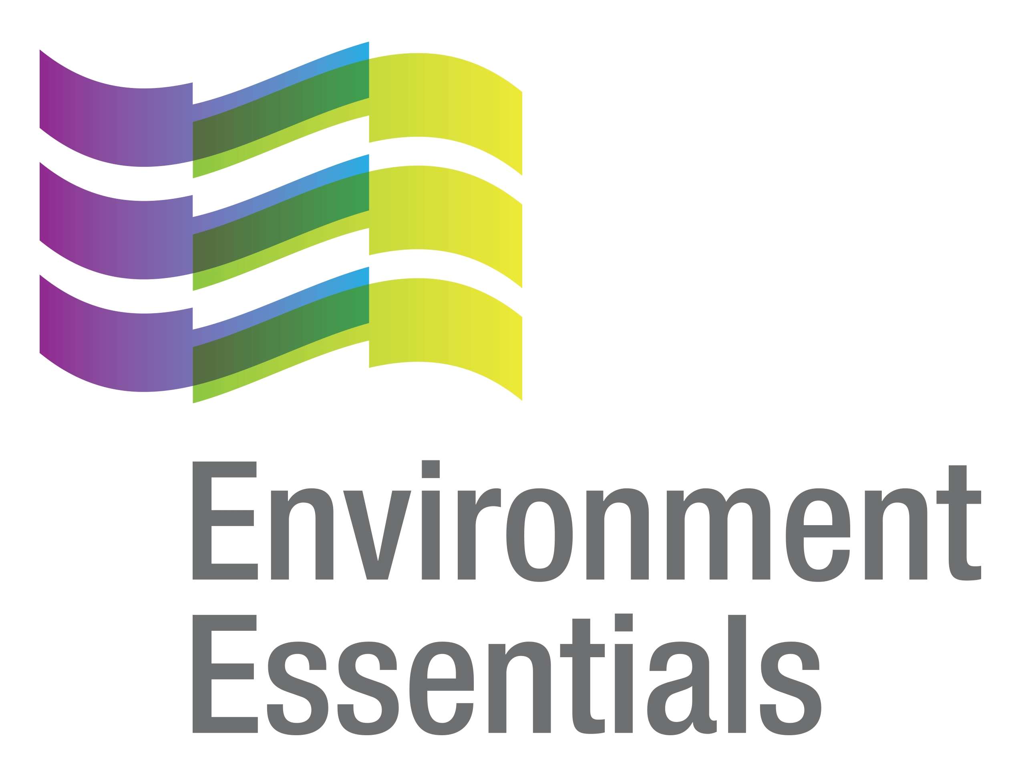 | COVID-19 (Novel Coronavirus)

Wednesday 13 May 2020
Please find below a selection of recent legislation changes relating to COVID-19 and communications for workplaces from key safety and environmental regulators in Australia and New Zealand.
This update is intended to be provided on a weekly basis.
Please note: The legislation in this update was current at time of release. Legislation around COVID-19 is being frequently updated and revoked. The URLs provided may no longer be maintained by the relevant legislation website, after the release date.

Legislation changes

Commonwealth

Anti-Money Laundering and Counter-Terrorism Financing Rules Amendment Instrument 2020 (No. 2) - makes it explicit that where it is not possible to verify information, in accordance with an applicable customer identification procedure, based on an original, or certified copy or certified extract, of a document due to COVID‑19 pandemic measures, a reporting entity may rely on a copy of a document.

Corporations (Coronavirus Economic Response) Determination (No. 1) 2020 - deals with provisions about meetings and document signatures that are not compatible with public health requirements for social distancing during the COVID-19 pandemic.
- Financial Sector (Collection of Data) (Reporting Standard) Determination No. 5 of 2020 - determines a new Reporting Standard ARS 331.0 Selected Revenue and Expenses.
- Financial Sector (Collection of Data) (Reporting Standard) Determination No. 6 of 2020 - determines a new Reporting Standard ARS 331.0 Selected Revenue and Expenses.
- Structured Finance Support (Coronavirus Economic Response Package) (Delegation) Amendment (Definition of Smaller Lender) Direction 2020 - amends the Structured Finance Support (Coronavirus Economic Response Package) (Delegation) Direction 2020.

ACT
- Corrections Management (COVID-19 Temporary Leave) Operating Procedure 2020 - facilitates the effective and efficient management of correctional services.
- Leases (Commercial and Retail) COVID-19 Emergency Response Declaration 2020 - introduces the requirement for good faith negotiations between the landlord and tenant, having regard to the overarching principles and leasing principles set out in the National Code, prior to the landlord terminating the lease or taking adverse action for a prescribed breach.
- Public Health (Closure of Non-Essential Business or Undertaking) Emergency Direction 2020 (No 6) - revokes and replaces the Public Health (Closure of Non-Essential Business or Undertaking) Emergency Direction 2020 (No 5).
- Public Health (Non-Essential Gatherings) Emergency Direction 2020 (No 3) - revokes and replaces the Public Health (Non-Essential Gatherings) Emergency Direction 2020(No 2).
- Public Health (Returned Travellers) Emergency Direction 2020 (No 4) - revokes, replaces and extends the Public Health (Returned Travellers) Emergency Direction 2020 (No 2) and the Public Health (Returned Travellers) Emergency Direction 2020 (No 3).
- Working with Vulnerable People (Background Checking) Amendment Regulation 2020 (No 1) - exempts Australian Defence Force personnel, and public employees of Commonwealth, state or territory entities, from registration under the Working with Vulnerable People scheme while engaged in ‘regulated activities’ on behalf of the Territory for the purposes of supporting the COVID-19 emergency.

NSW
- Exemption from Certification for Diagnostic Imaging Apparatus - reduces the potential health risks associated with the COVID-19 pandemic to Consulting Radiation Experts who are required to attend inspections on-site, and to reduce pressure on the delivery of medical services such as diagnostic imaging.
- Exemption from On-Site Supervision Requirements - provides temporary relief from the requirement to be on-site for diagnostic procedures while the COVID-19 pandemic is being managed.
- Exemptions for Persons on AHPRA Pandemic Response Sub-register - enables persons listed on the “pandemic response sub-register” published by the Australian Health Practitioner Regulation Agency to return to the workforce to meet the increased need during the COVID-19 pandemic.
- Public Health (COVID-19 Restrictions on Gathering and Movement) Amendment (Real Estate) Order 2020 - enables persons to gather at certain premises to view or inspect for the purpose of sale or lease.

NT
- Residential Tenancies COVID-19 Modification Notice Amendment 2020 - amends the Residential Tenancies COVID-19 Modification Notice 2020.

QLD
- Land (COVID-19 Emergency Response - Waiver and Deferral of Rents and Instalments) Regulation 2020 - provides rent relief for businesses who rent premises from the State government to mitigate the financial impact arising from the COVID-19 pandemic.
- Superannuation (State Public Sector) Amendment of Deed Regulation 2020 - introduces terminal medical condition as a condition of release to the defined benefit category, which will give impacted members access to the death benefit that would have otherwise become available in the future.

SA

COVID-19 Emergency Response (Bail) Amendment Act 2020 - specifies a number of additional offences against the Criminal Law Consolidation Act 1935 that will attract the presumption against bail during the COVID-19 period.

TAS
- COVID-19 Disease Emergency (Miscellaneous Provisions) Act (No. 2) 2020 - provides for special measures, related to the social effect of, and the risk of the spread of, COVID-19 by amending, or modifying the application of certain Acts.
- Direction Under Section 16 of the Public Health Act 1997 (Gatherings (North-West Region) - No. 4) - restricts the operation of certain retail or commercial premises and services.
- Extension of Emergency Declaration - extends the public health emergency declared under Section 14 of the Public Health Act 1997 for a further 7 days.

VIC

- Care Facilities Directions (No 3) - provides for restricted access to care facilities.
- Diagnosed Persons and Close Contacts Directions - requires person diagnosed with COVID-19 to self-isolate, and persons living with a diagnosed person or in close contact with a diagnosed person to self-quarantine.
- Extension of Declaration of a State of Emergency - further extends the declaration made on 16 March 2020 under S 198(1) of the Public Health and Wellbeing Act 2008 on 16 March 2020 until 11:59 PM on 31 May 2020.
- Hospital Visitor Directions (No 3) - prohibits non-essential visits to hospitals to limit the spread of COVID-19.
- Pharmacist Supply on a Digital Image (PHEO #4 as Amended) - facilitates certain registered practitioners to deal with certain schedule 4 poisons, enables pharmacists to sell or supply certain schedule 4 poisons on an electronically transmitted digital image of an original prescription, and amends PHEO #4 to clarify certain requirements.
- Restricted Activity Directions (No 7) - restricts the operation of certain businesses and undertaking to limit the spread of COVID-19.
- Stay at Home Directions (No 6) - requires persons to limit their interactions with others.

WA

Extension of Duration of Public Health State of Emergency Declaration - further extends the duration of the public health state of emergency declaration for a period of 14 days.
- Local Government (COVID-19 Response) Order 2020 - provides for matters relating to local government during the COVID-19 emergency period.

NZ
- Auckland Transport Emergency Speed Limit - sets emergency speed limits.
- COVID-19 Response (Taxation and Other Regulatory Urgent Measures) Act 2020 - assists the Government’s response to impacts of the COVID-19 outbreak.
- Epidemic Preparedness (Customs and Excise Act 2018 - Appeals) Immediate Modification Order 2020 - modifies restrictions imposed by the Customs and Excise Act 2018 that may be impossible or impracticable to comply with during an epidemic.
- Nelson City Council City Centre Emergency Speed Limit - sets emergency speed limits for parts of the Nelson city centre.
- Wellington City Council - South Coast Roads Emergency Speed Limit - sets an emergency speed limit.

From the regulators

Australia
- National Offshore Petroleum Safety and Environmental Management Authority: Encouraging Results from COVID-19 Inspections
- Therapeutic Goods Administration:
  - Amendments to the New Restrictions on Prescribing Hydroxychloroquine for COVID-19
  - Promedical Equipment Fined $63,000 for Alleged Unlawful Advertising of a COVID-19 Rapid Test Kit
  - WA Woman Fined $2,520 for Alleged Breaches in Relation to COVID-19 Test Kits
- Transport and Infrastructure Council: Communique 6 May 2020

ACT

ACT Government:
  - Dispute Resolution for Residential Tenants and Landlords
  - Some Easing of COVID-19 Restrictions Begins
  - Staged Return to On-Campus Learning in ACT Public Schools
  - Statement: ACT Chief Minister
  - Supporting Aboriginal and Torres Strait Islander Organisations to Respond to COVID-19
  - $4.5 Million COVID-19 Mental Health Support Package to Help Canberrans

NSW

State Insurance Regulatory Authority: SIRA Bulletin

QLD

Department of Natural Resources, Mines and Energy:

COVID-19 DNRME Updates - Updated 11 May 2020
  - Explorers Invited to Stake Their Claim in $2.8 Million
  - Multi-million Dollar Relief Package for Explorers

QLD Government:
  - COVID-19 Assistance for Tourism Lease, Licence and Permit Holders
  - Payroll Tax Exemption on JobKeeper Payments
  - Premier Maps Road to Easing Restrictions
  - Price Freeze Offers Further Relief for Farmers
  - Qld COVID-19 - Tue May 5: Economic Resumption Planning Continues
  - Qld COVID-19 - Thu May 7: Home Visit Rules Ease / Business Plans Progress
  - Qld COVID-19 - Fri May 8: Roadmap Released / No New Cases / More Recoveries
  - Queensland Doubles Funding for 12-Month Interest Free Business Loans

SA
- Return to Work SA: ReturnToWorkSA and the Coronavirus (COVID-19) - Updated 8 May 2020
- SA Government: COVID Restrictions to Ease from Monday

TAS
- Tasmanian Government: PPE Register to Support Local Businesses
- WorkSafe Tasmania: COVID-19 Safe Workplaces Framework

VIC

VIC Government: Coronavirus (COVID-19) Restrictions Victoria - Updated 11 May 2020

WA
- Department of Health: Dashboard Puts Local COVID Data Within Easy Reach
- Department of Mines, Industry Regulation and Safety:
  - Applications Open for COVID-19 Rent Relief Grant
  - Commissioner's Blog: Financial Relief for Renters
  - Guidance for Petroleum Title Holders Affected by the COVID-19 Pandemic
  - New Procedures to Support Mining Industry During COVID-19
  - Retail Work: Minimising the Risk of Exposure to COVID-19

WA Government:
  - Coming Together to Make COVID-19 Research a Priority
  - COVID Safety Plans Key to Reopening WA Businesses
  - Expanding Mandatory Testing to Better Protect Police During Coronavirus Pandemic
  - Fast-tracked Payments to Boost Local Businesses
  - Research Expanded to FIFO Workers to Track Possible COVID-19
  - The WA Roadmap for Easing COVID-19 Restrictions
  - Water Corporation Supports Kimberley Through New COVID-19 Community Relief Fund
  - $100m Short-Term Lending Facility to Support Local Governments and Universities Through COVID-19

NZ

Department of Conservation: Alert Level 2 - What it Means for DOC and Visitors

Ministry of Health:

COVID-19 Testing System Ready for Next Phase
  - New Measures to Bolster Aged Residential Care Safety During COVID-19

NZ Government:
  - APEC Economies Agree to Keep Markets Open and Trade Flowing in Response to COVID-19
  - Contact Tracing Audit Recommendations Implemented
  - Covid-19 Response: New Legal Framework as Move to Alert Level 2 Considered
  - Government Freezes Customs Fees to Boost Recovery
  - Insolvency Relief in Sight for Businesses Affected by COVID-19
  - Level 2 Announcement
  - New Zealand and Australia Enhance Defence Cooperation in the Fight Against COVID-19
  - Prime Ministers Jacinda Ardern and Scott Morrison Announce Plans for Trans-Tasman COVID-safe Travel Zone
  - Safe Domestic Travel Able to Resume at Alert Level 2
  - Temporary Amendment to Unit Titles Act Allows Body Corporates to Meet Virtually
  - $25 Million for Innovative Solutions in Response To COVID-19
- WorkSafe NZ: Operating Safely at Alert Level 2 - What You Need to Think About

That completes this edition of the COVID-19 update. The next update will be released on Wednesday 20 May 2020.

Environment Essentials Pty Ltd ǀ ABN: 29 103 207 638
A Suite 8 / 8 Clay Drive, Doncaster Vic 3108, Australia ǀ T +61 3 9095 6533
W www.enviroessentials.com.au

